**Apache Kafka** - A high throughput system for moving vast amount of data with scalable and fault tolerant way

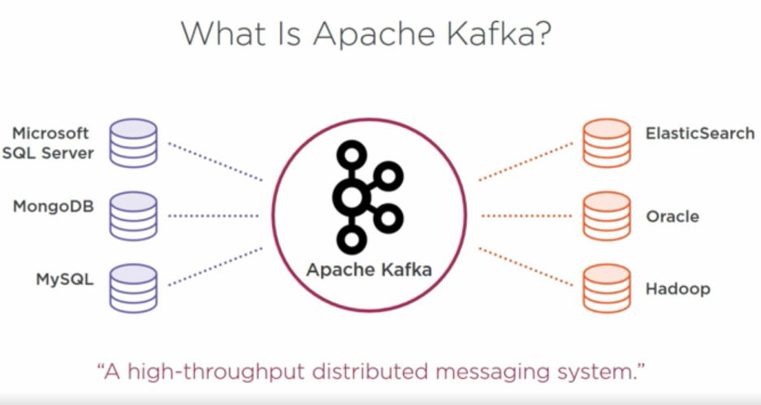

Current applications diagram

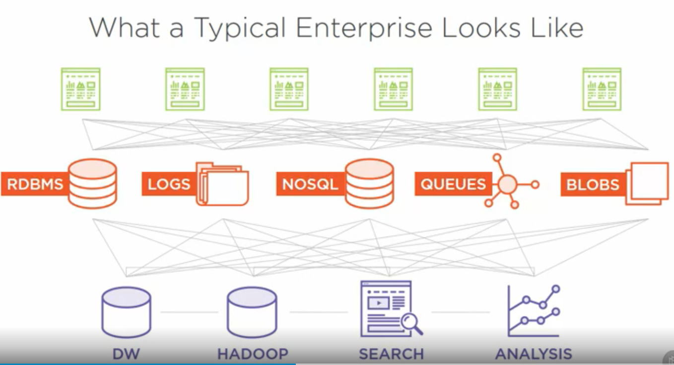

Current Solution – Tools used to solve the above problem (other than kafka)

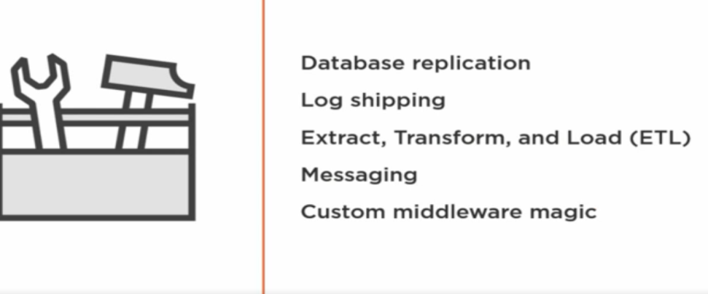

Database replication problem –

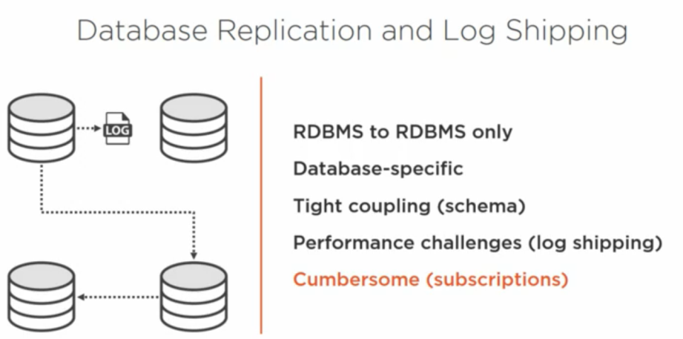

ETL challenges - costly, ETL experts required, complex and performance and scalability is challenging

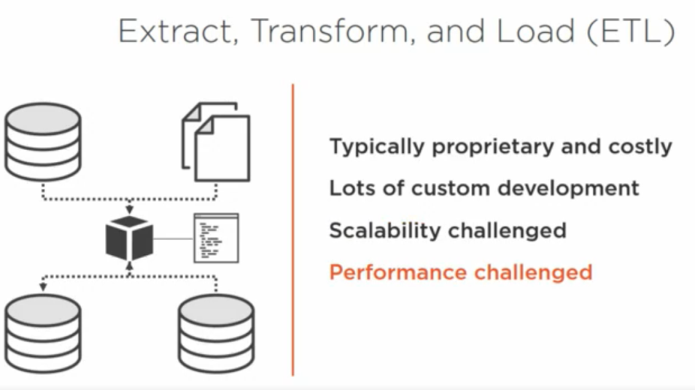

Messaging – provides a simple solution of passing data between applications. However current messaging systems fail in scalability since they depend on message brokers

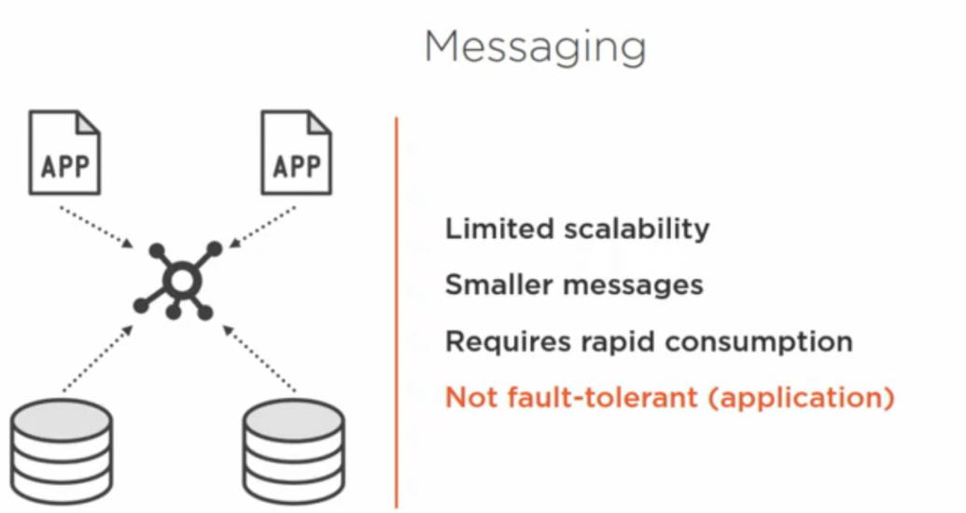

Perils of high messaging under high volume

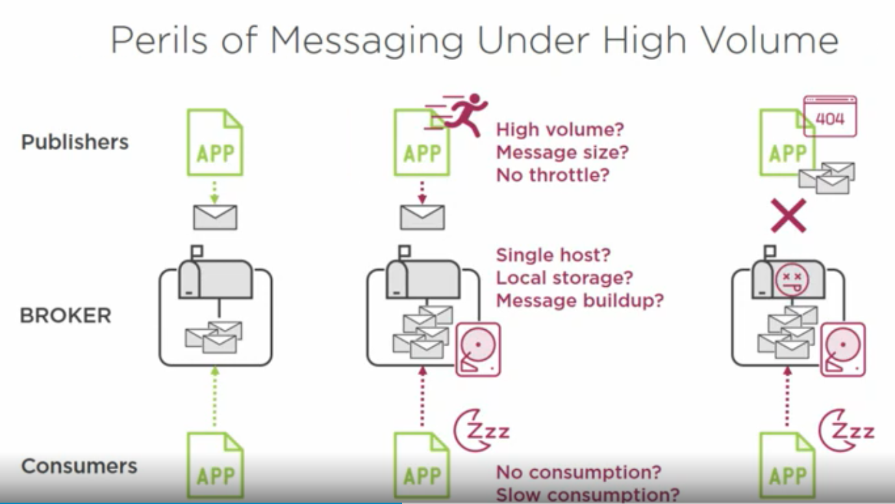

Consumer messaging faults –You can always log in somewhere to retrieve it later ,but that involves extra coding

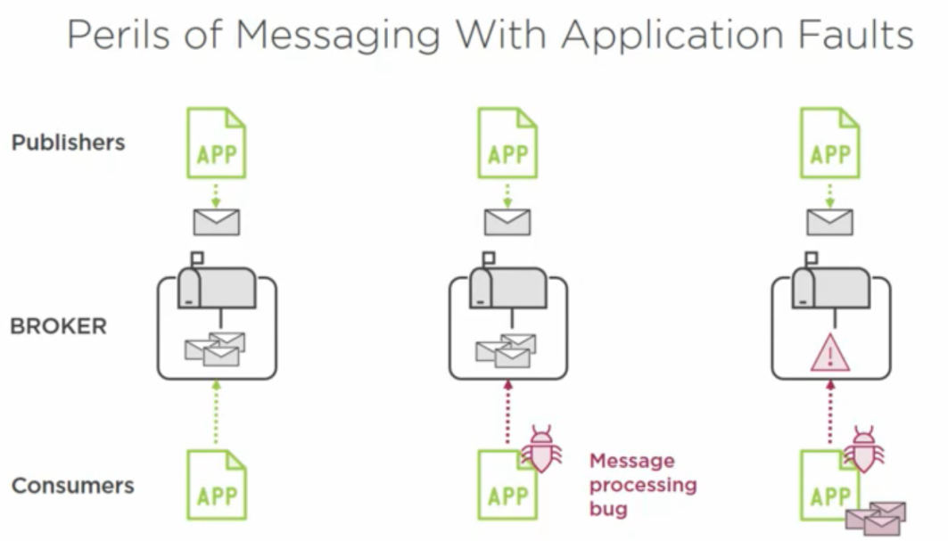

Writing your own middleware – Problems with this approach

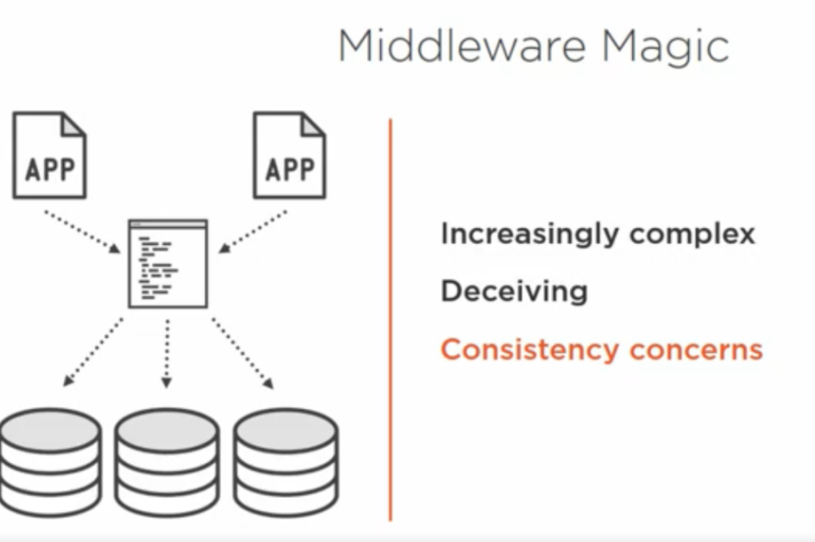

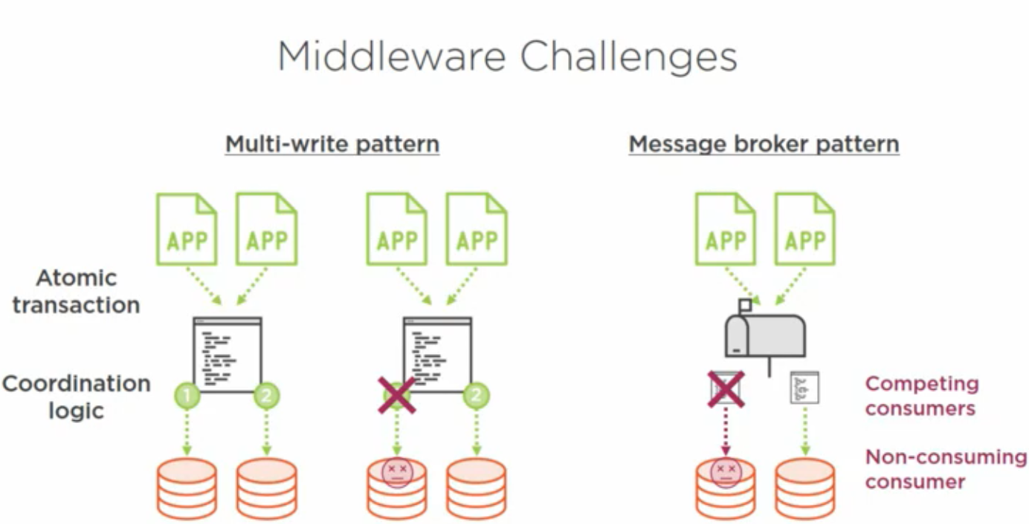

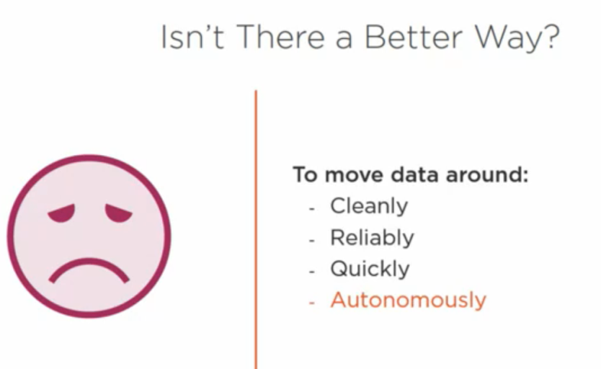

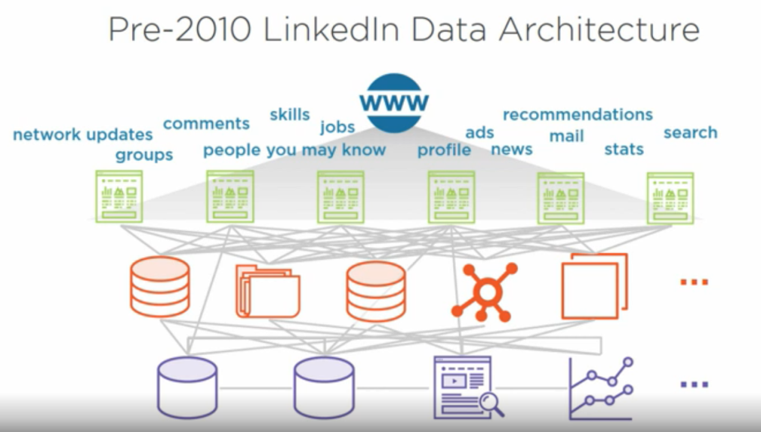

Kafka Goals

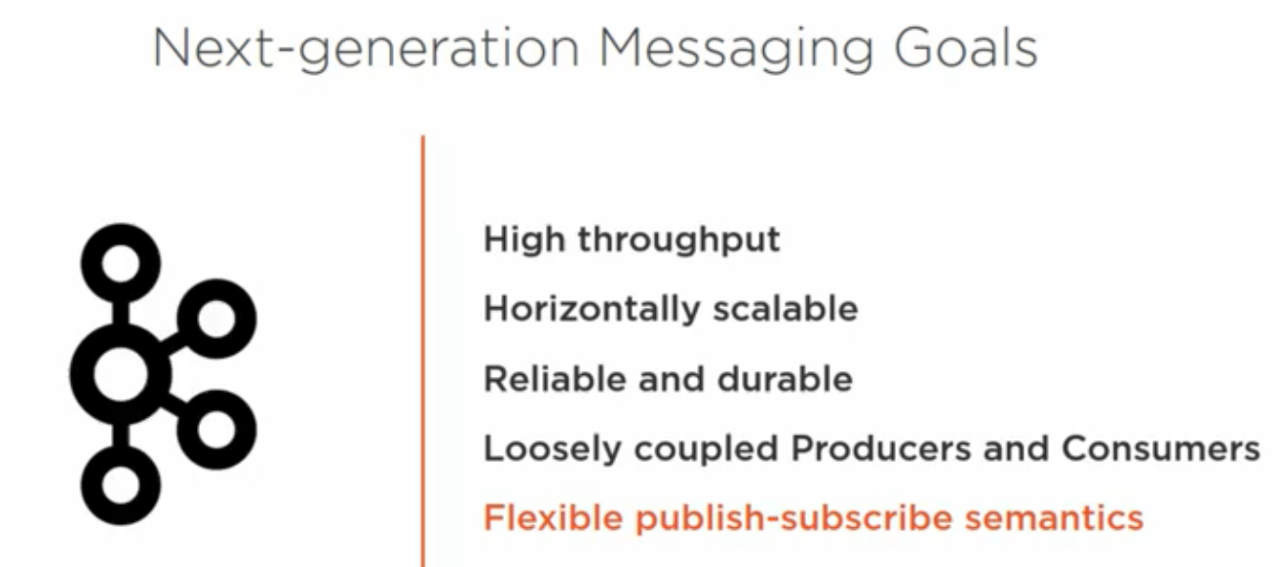

Linked in post Kafka

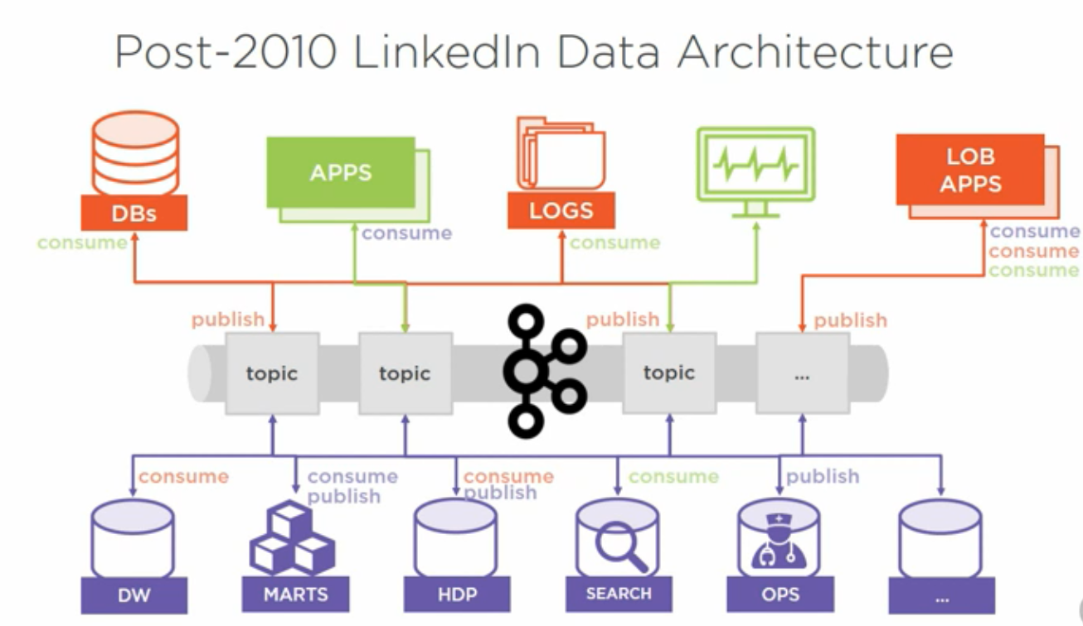

Summary

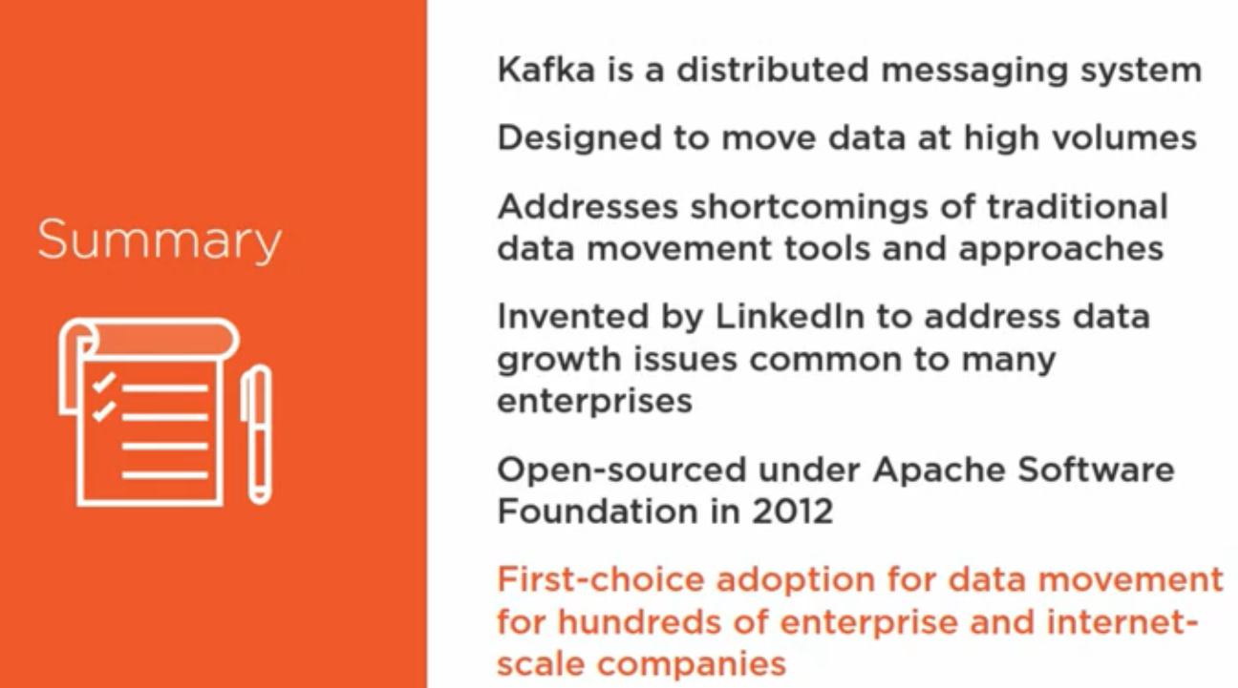

Kafka Topic

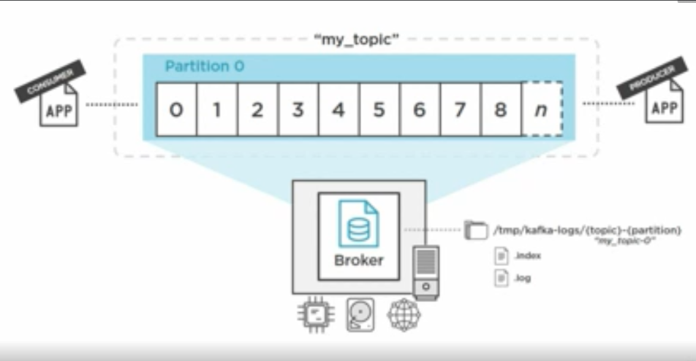

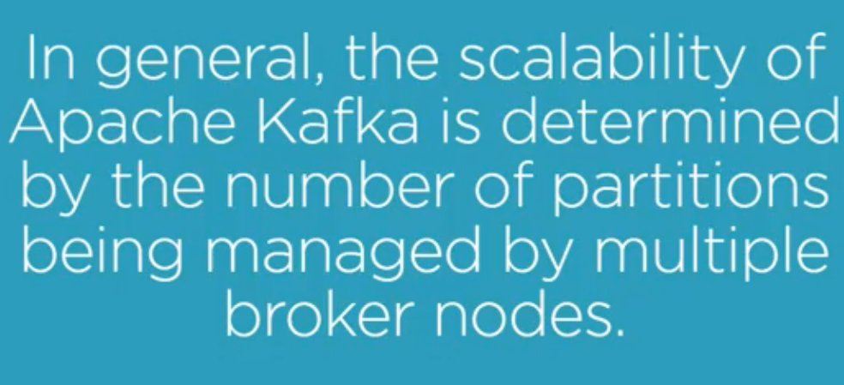

Topic and Partition ( Every partition gets unique message and this is determined by the partition strategy)

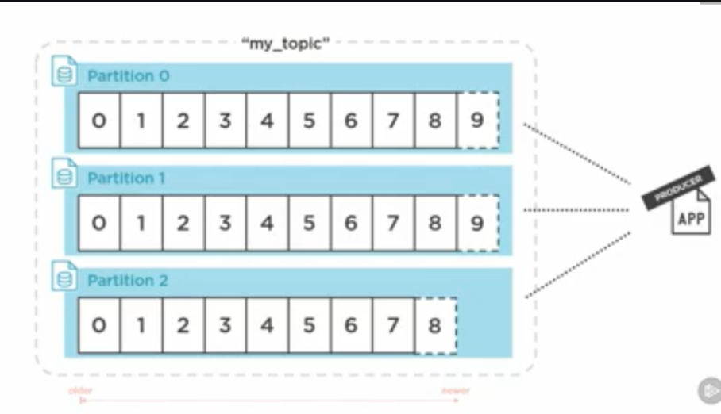

Process when topic with partition is to be created 1. Request goes to ZK (it finds the available broker) 2. Assigns partition to leaders. 3. Does status check of all brokers.

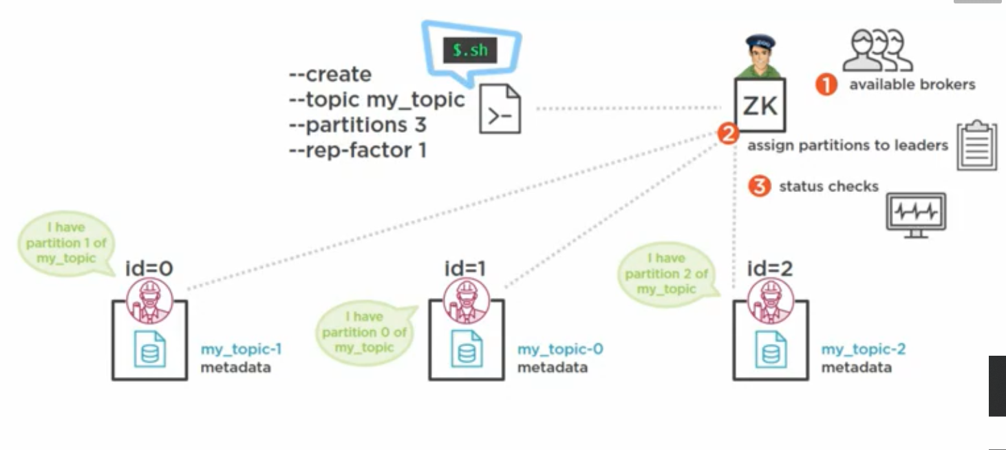

Producer sending data – Producer needs to know at least one broker. The broker sends information (metadata) containing all partitions of the topic and their respective brokers where they reside. Once it gets metadata of all partitions then sends data to respective partition using the partition strategy.

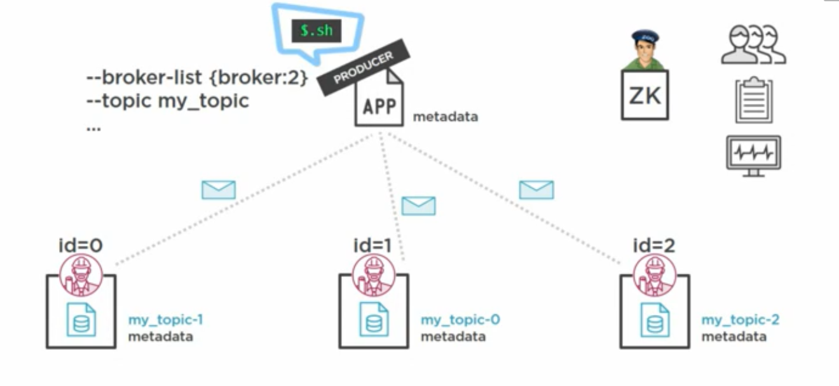

Consumer talks to Zookeeper to retrieve which broker owns which partition .Once it gets all of the details ,then based on the partition (either provided by consumer or assigned by Kafka) it fetches the data .It gets the offset from __consumer_offset topic which is internal topic in Kafka (Consumer can also provide the custom offset).Every broker has it’s own __consumer_offset topic to track the offset

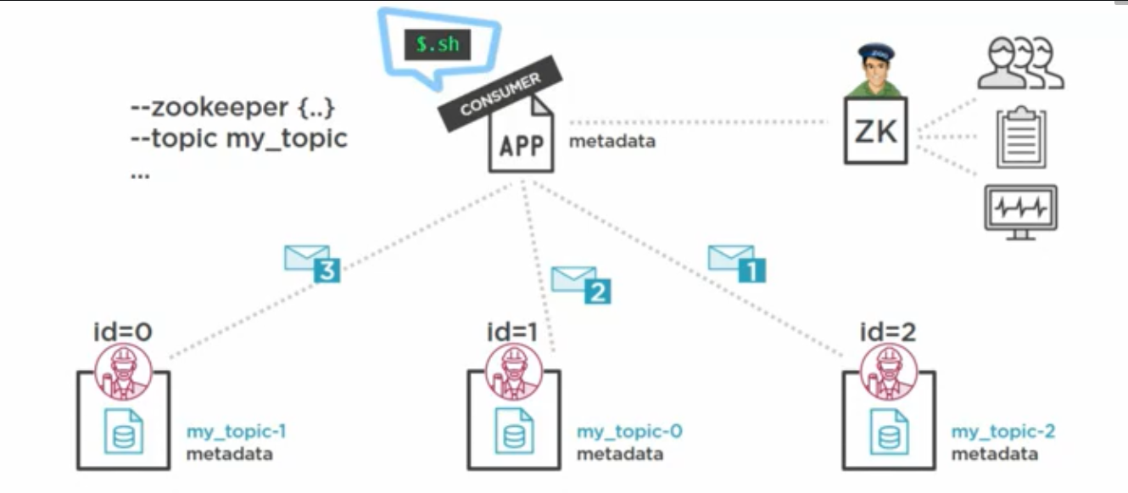

6 Consumer group

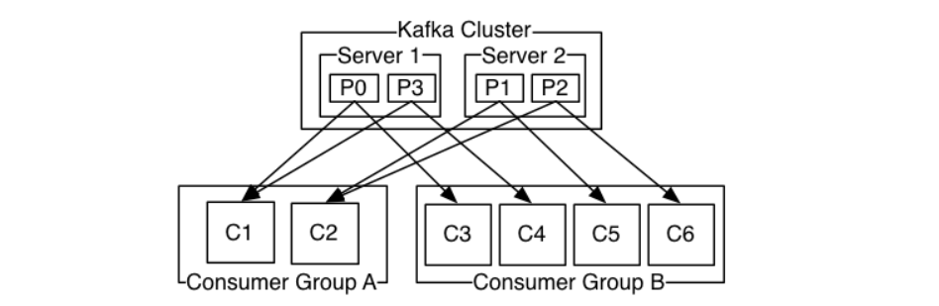

__consumer_offset details (every broker has this topic)

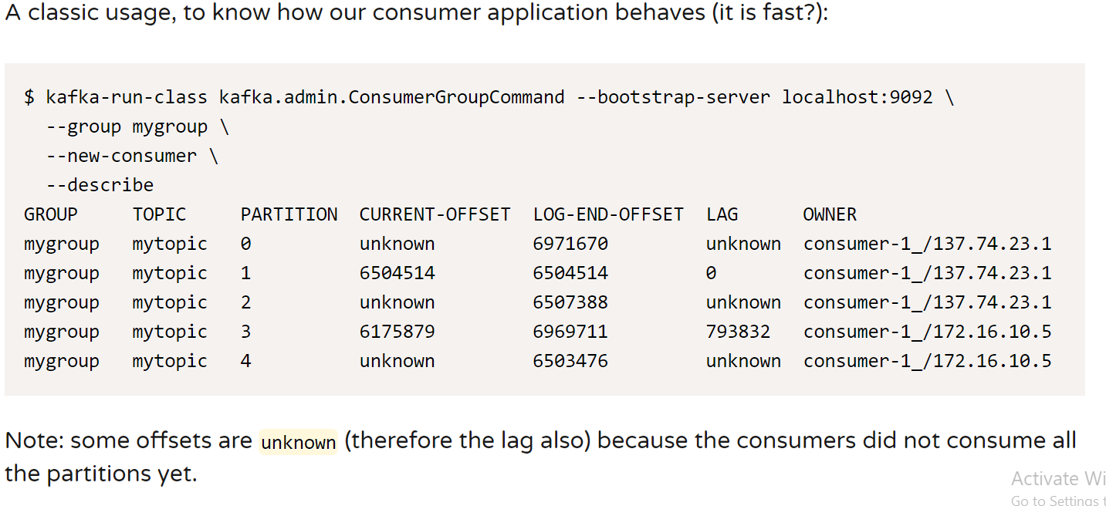

7. Replication factor = 3 (How every partition has it’s own replication replicas)

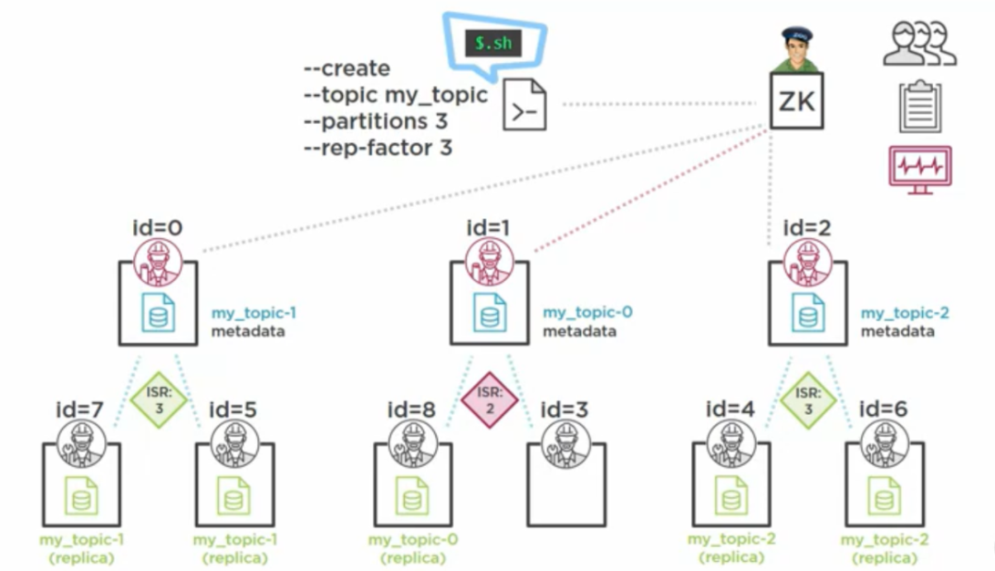

8 Kafka producer internals

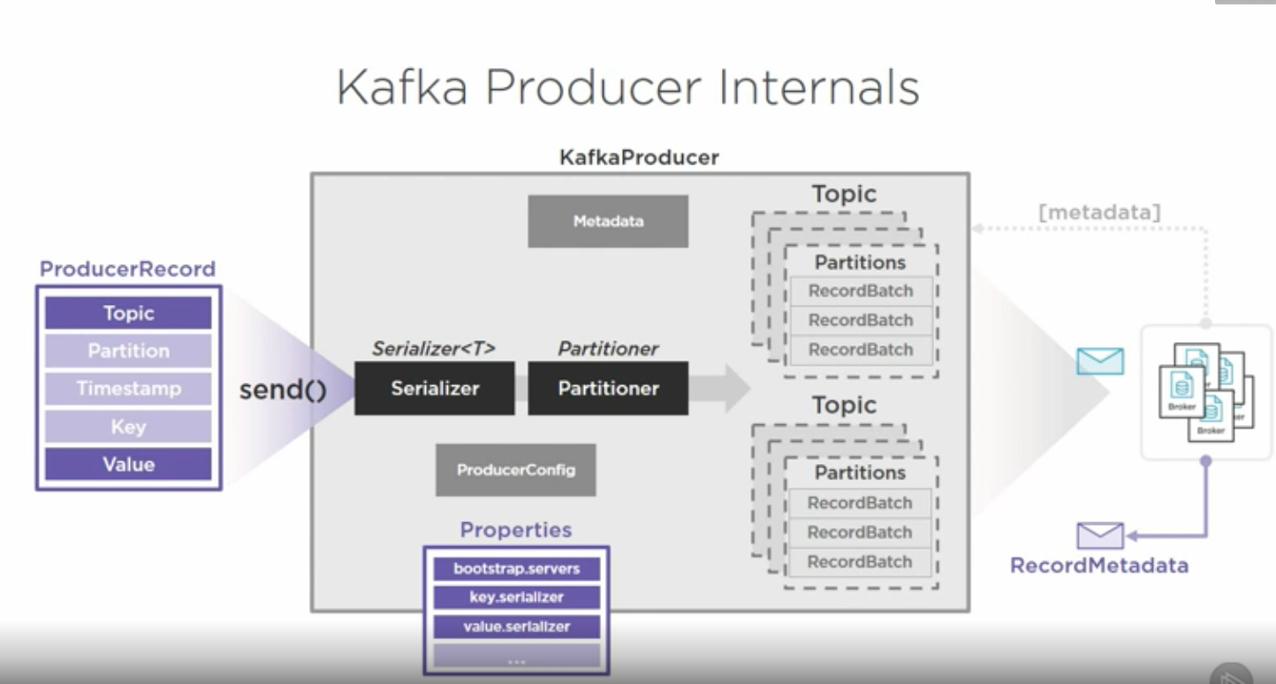

Send message part 1

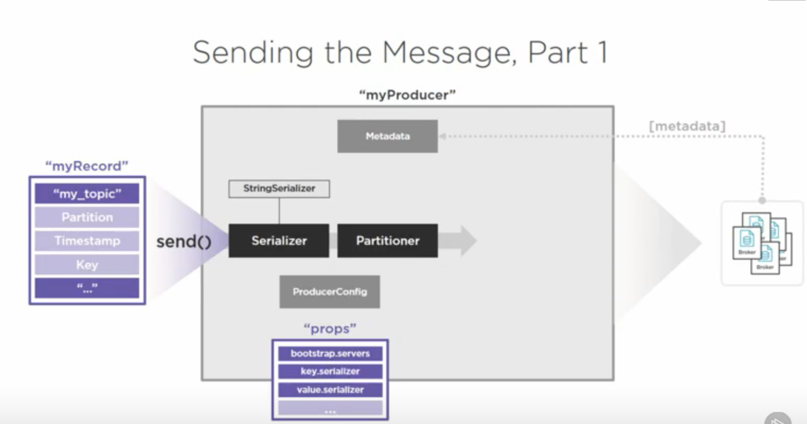

Kafka Producer Partitioning strategy

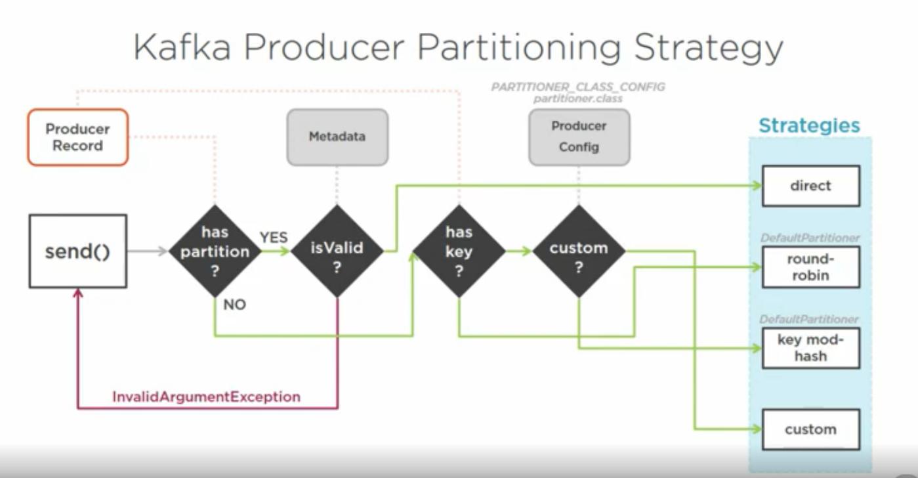

Sending message part 2

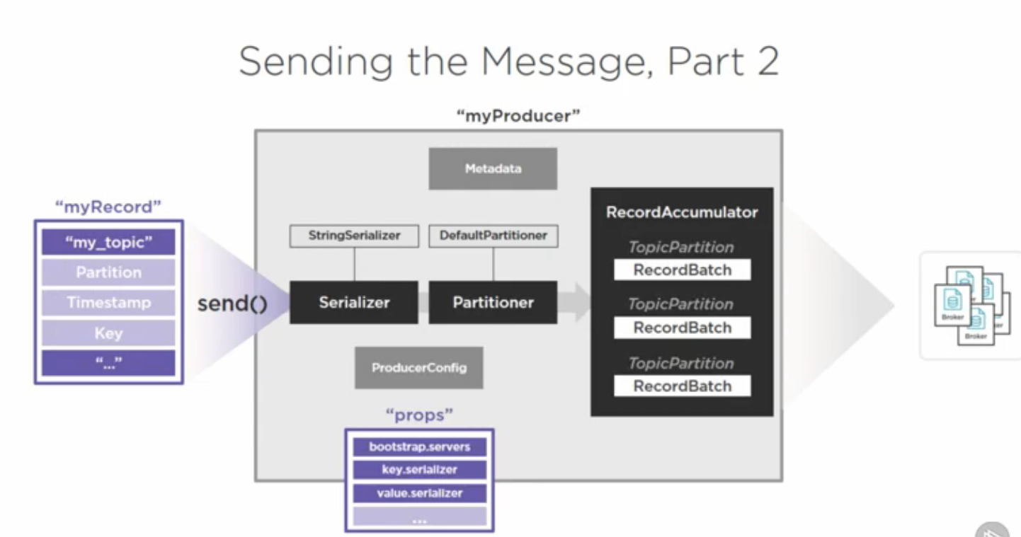

Message buffering

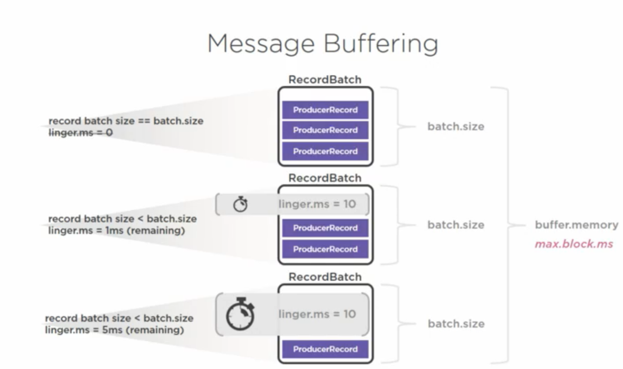

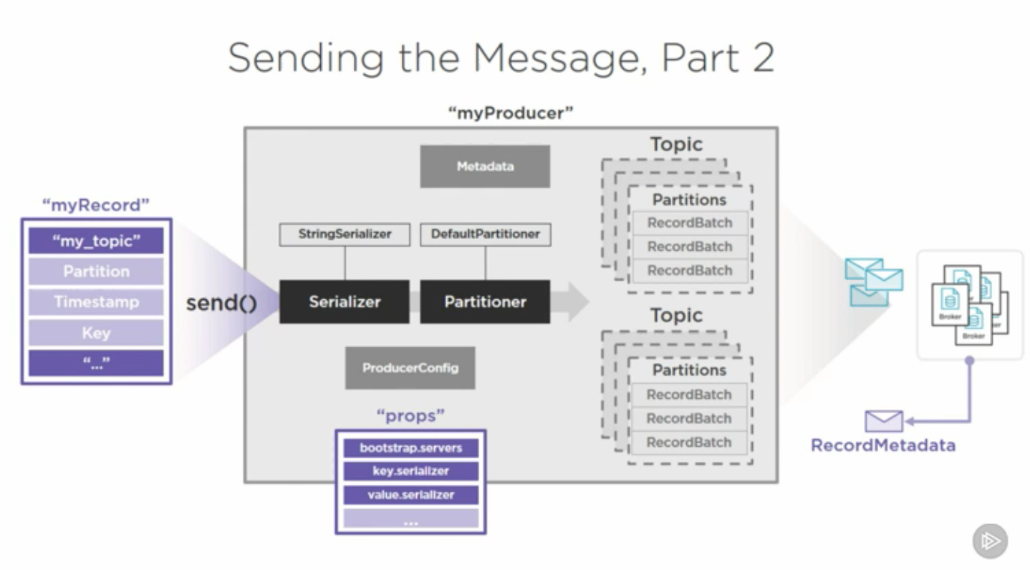

Delivery guarantees

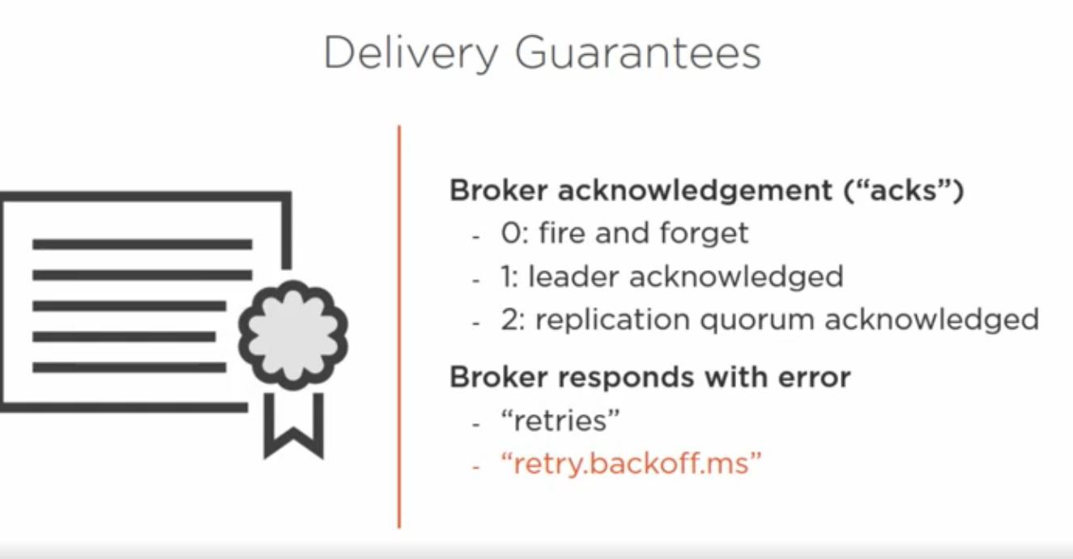

Ordering guarantees

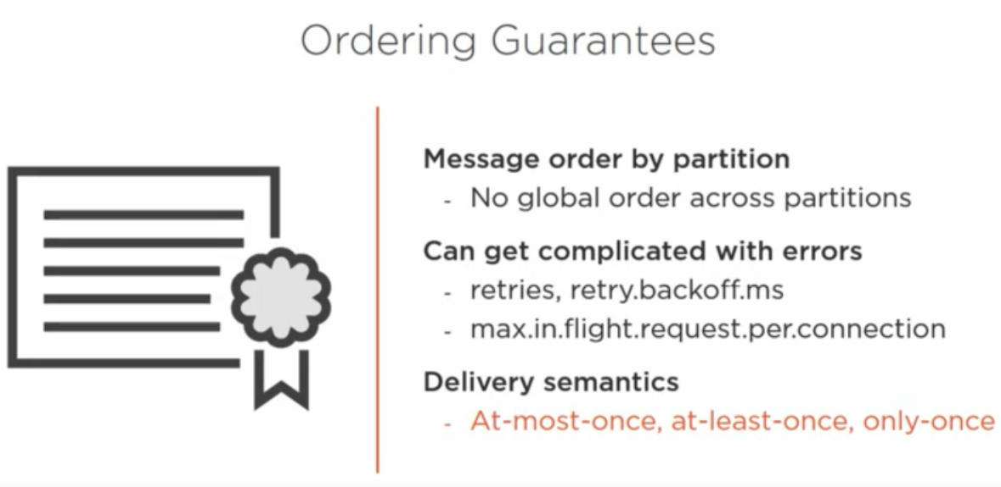

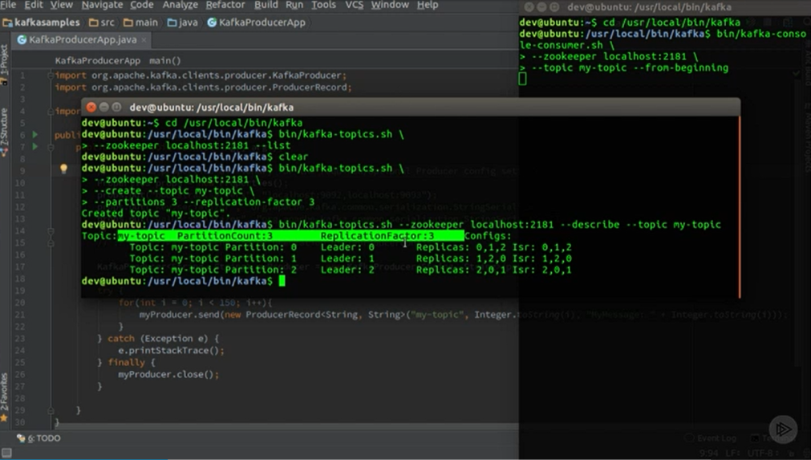

Send 150 messages to partitioned topic

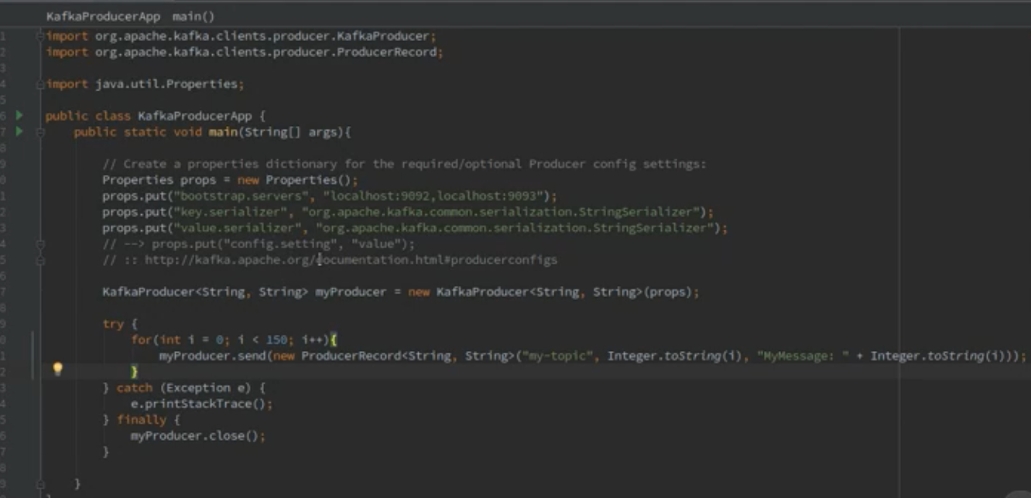

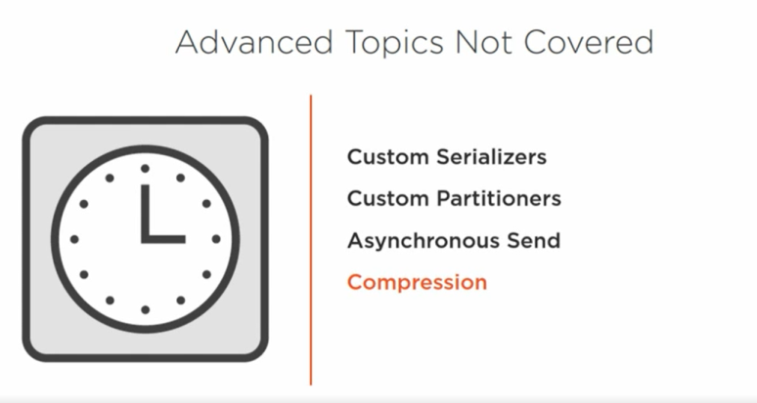

Consumer details

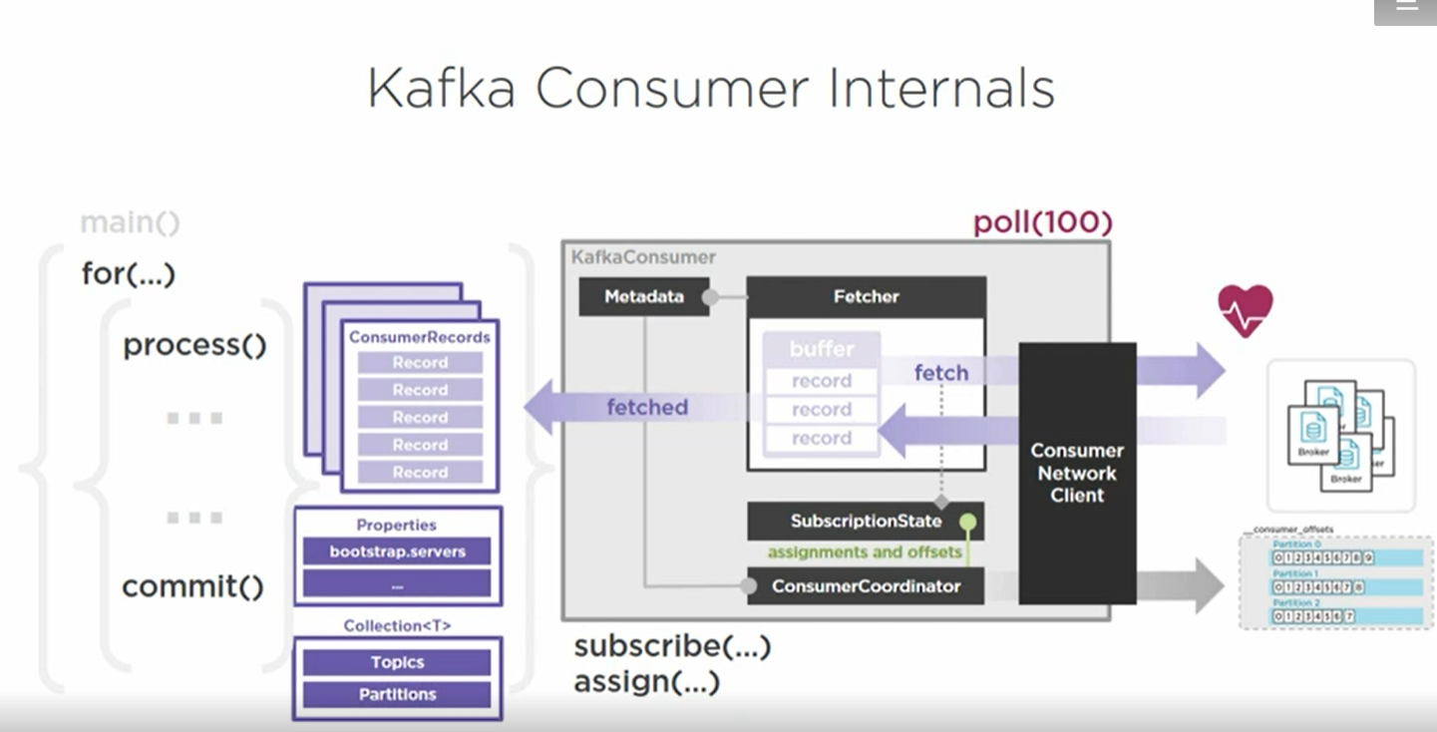

Properties

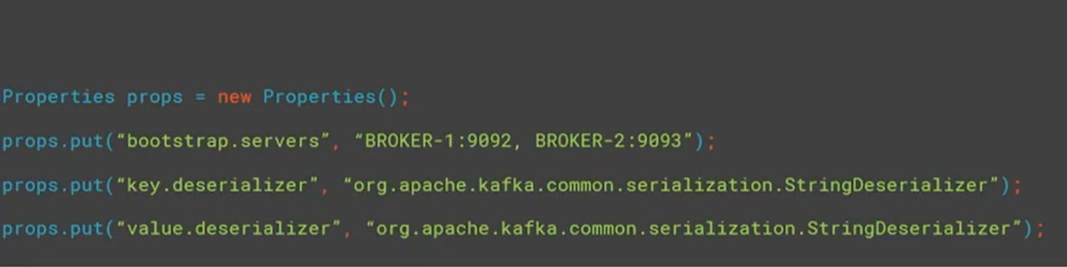

subscribe() and assign()

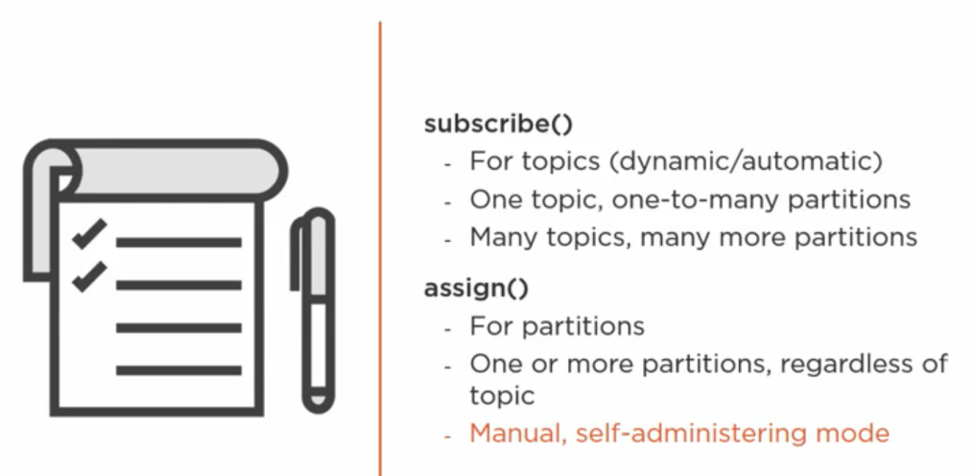

Manual partition assignment

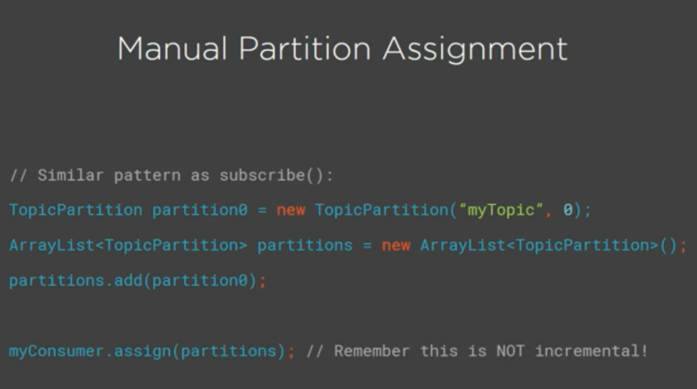

Single consumer topic subscription

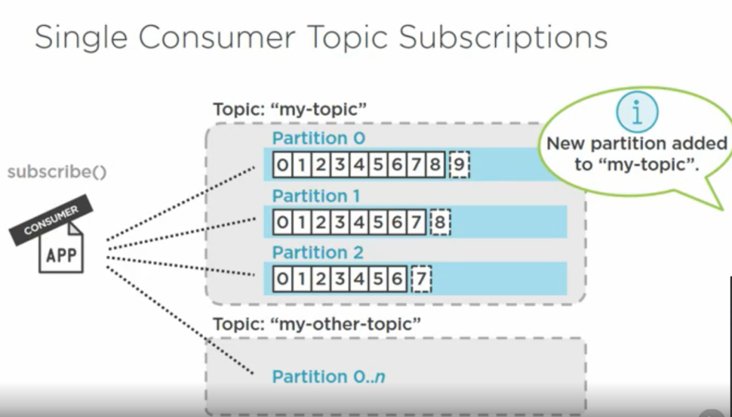

Single consumer partition subscription

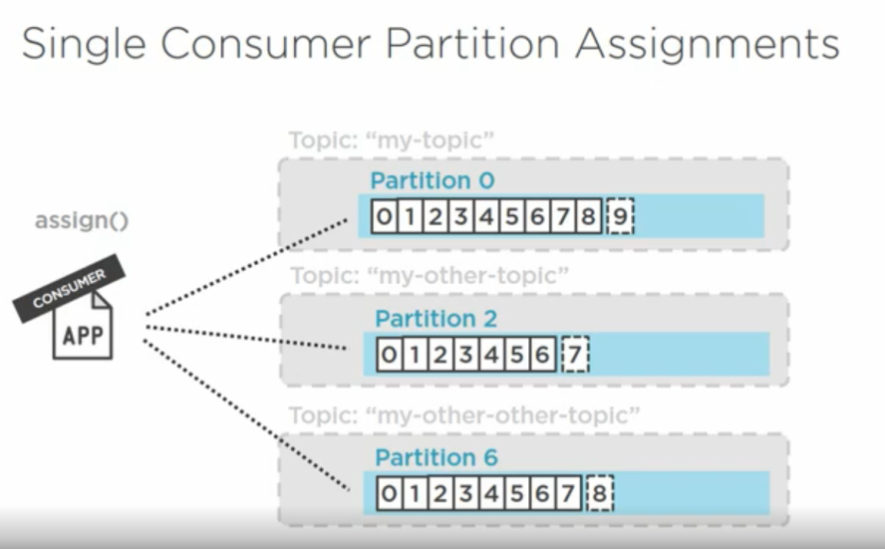

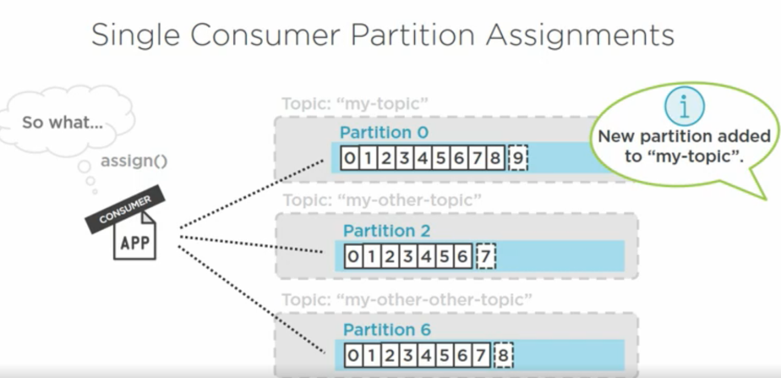

The poll loop

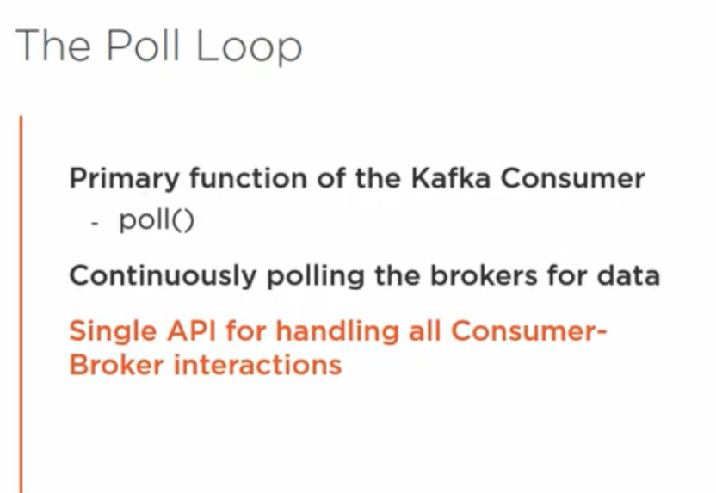

Demo

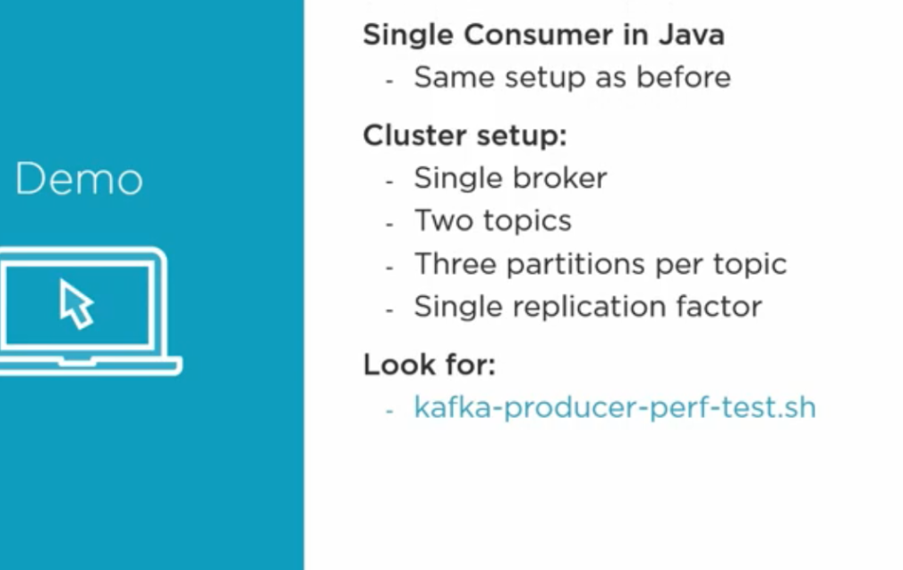

Kafka producer perf script

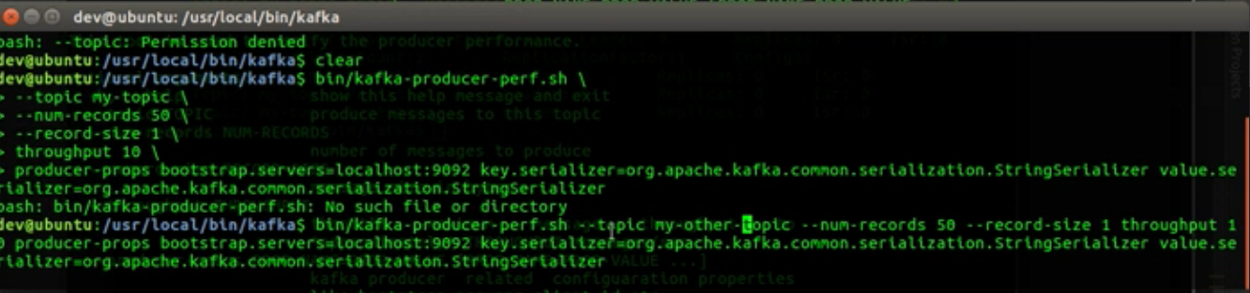

Kafka consumer poll

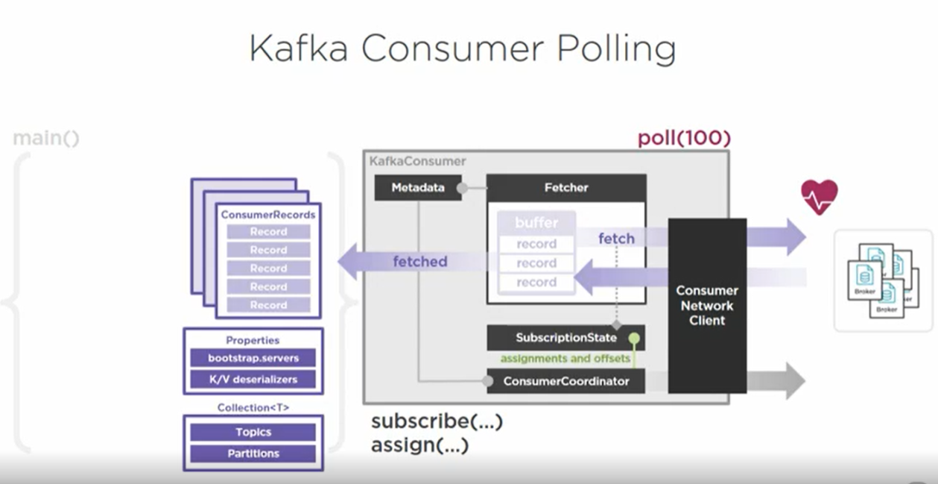

Processing of messages

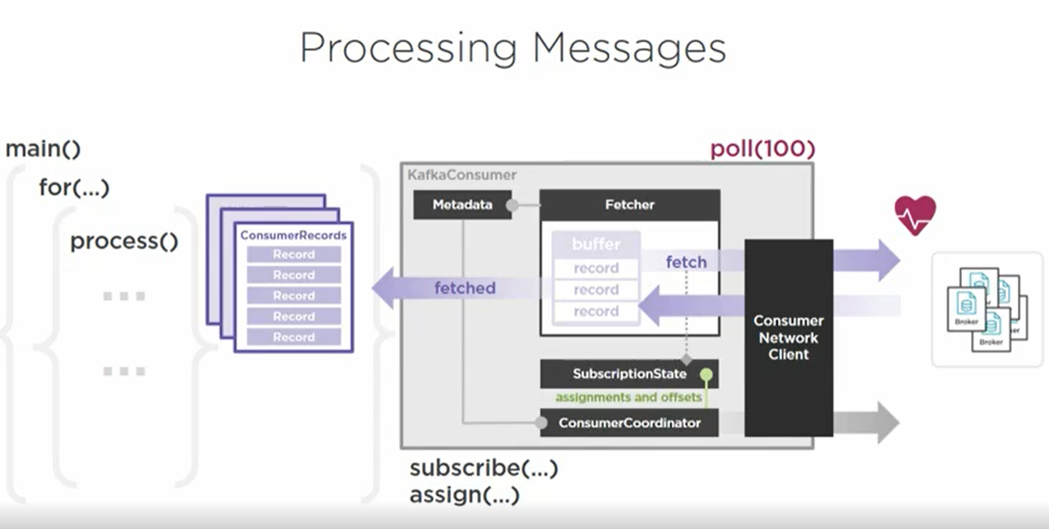

Mind the (Offset) gap

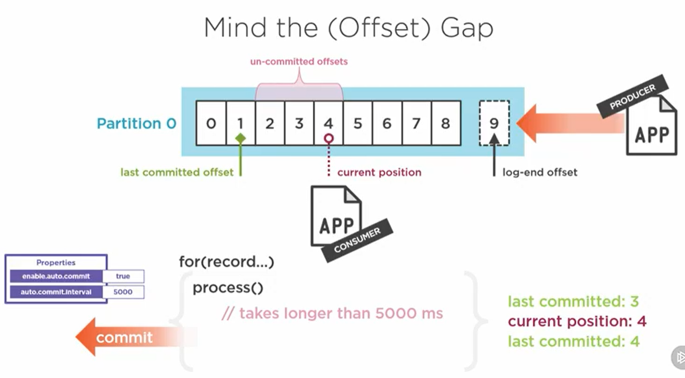

Offset Behavior

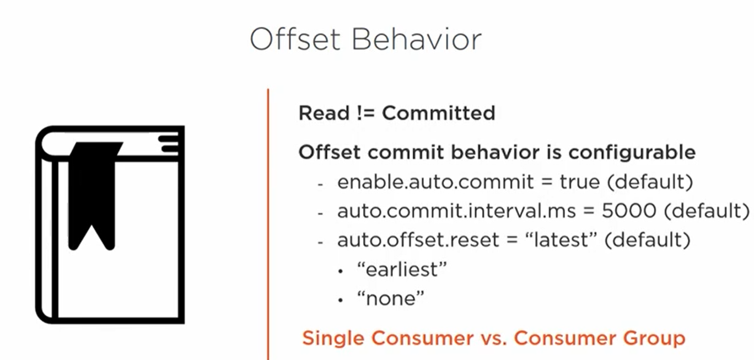

Storing the offset

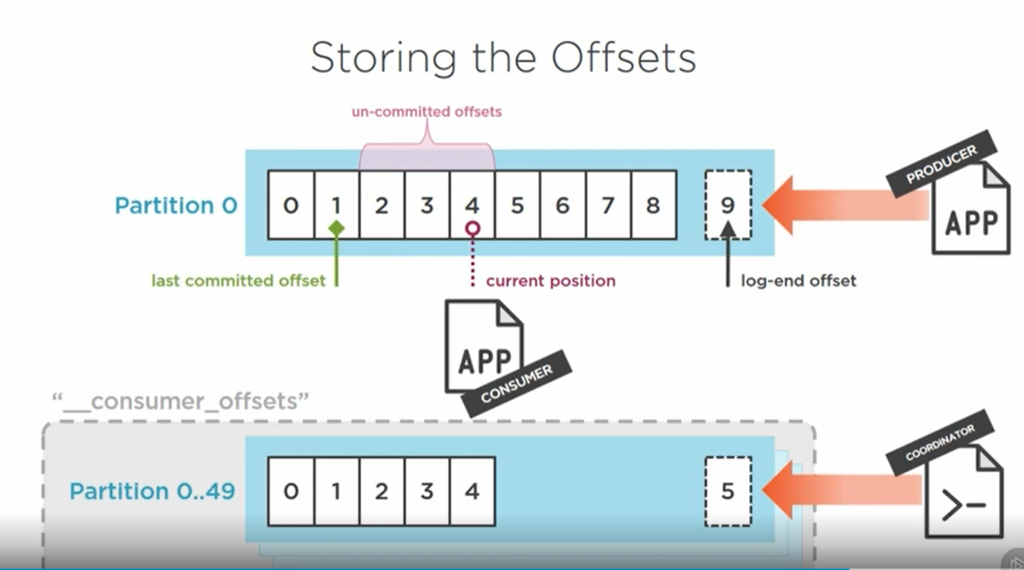

Commit sync

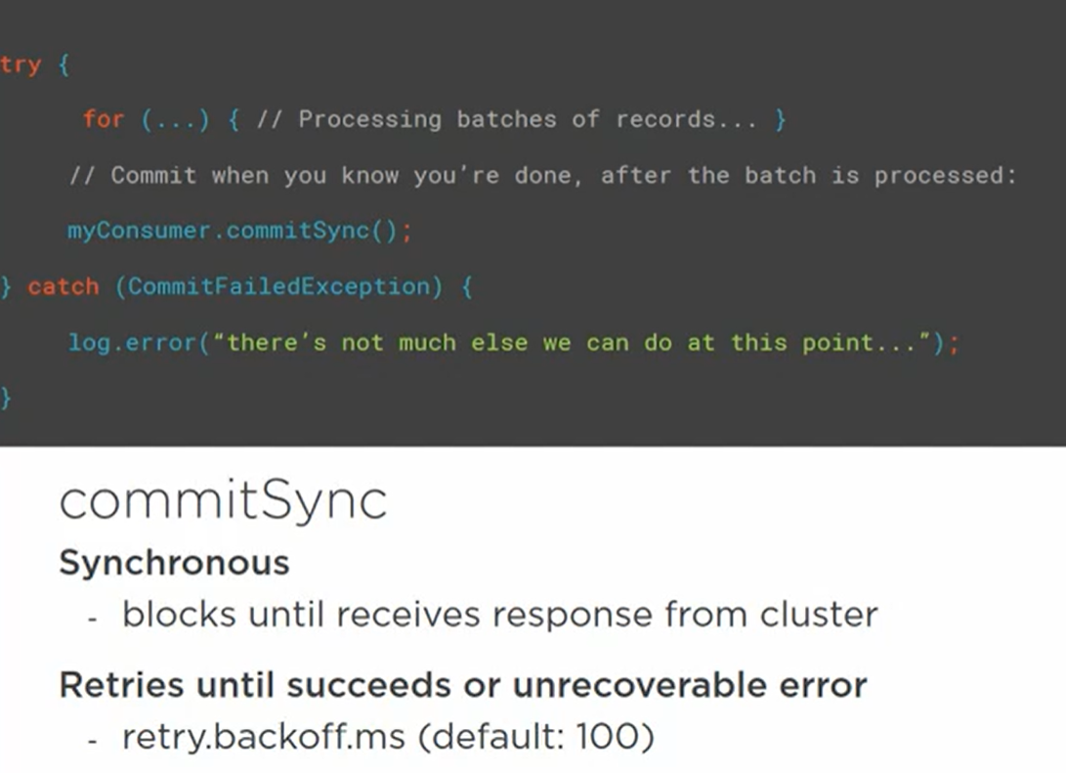

Async Commit

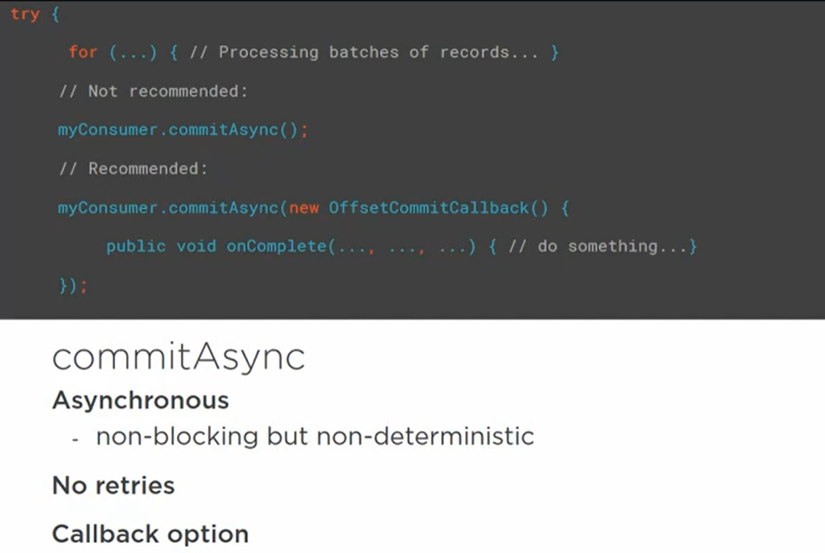

Committing offset

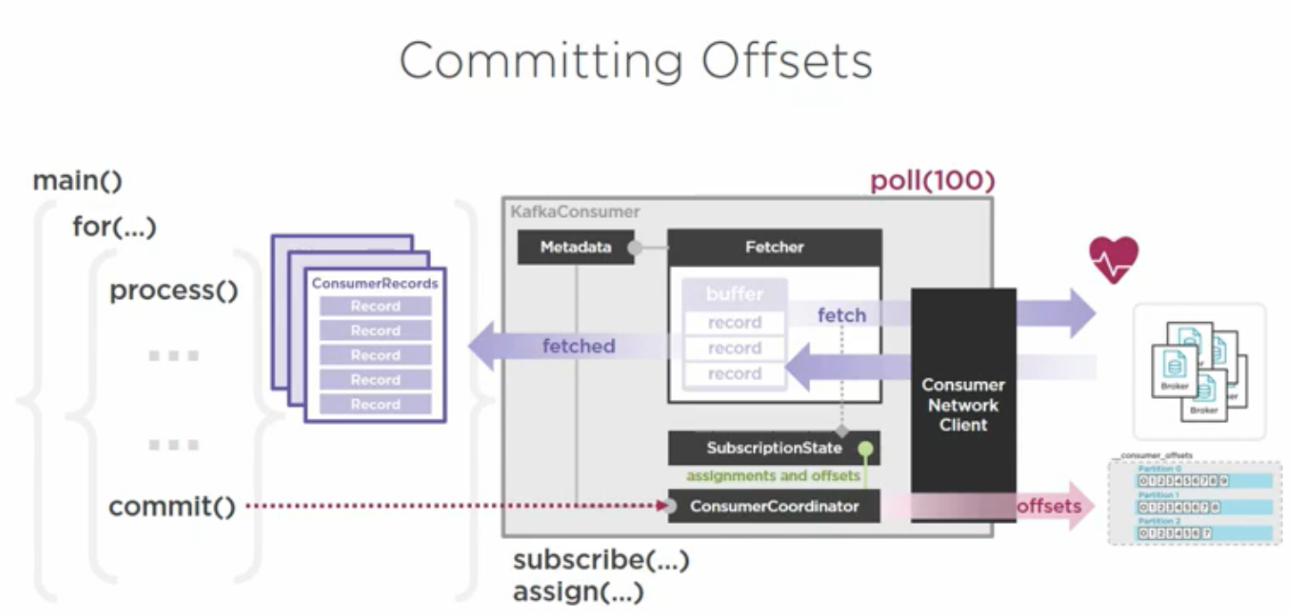

Commit is sent to ‘Consumer Coordinator’ who then updates the offset in ‘__consumer_offsets’ topic

It also updates ‘subscriptionState’ that updates the ‘fetcher’ so that ‘consumer Network Client’ can poll next messages

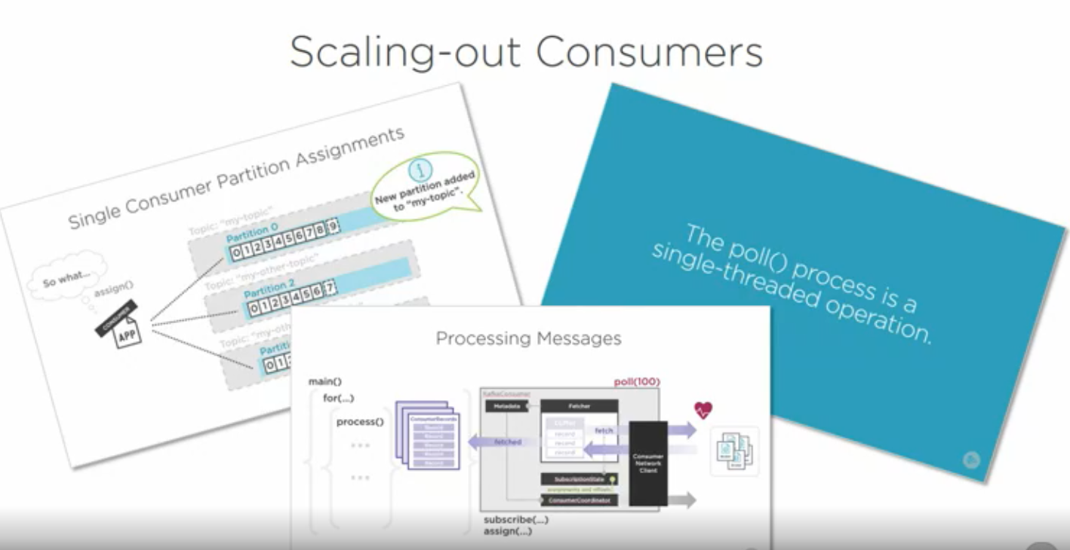

Consumer groups

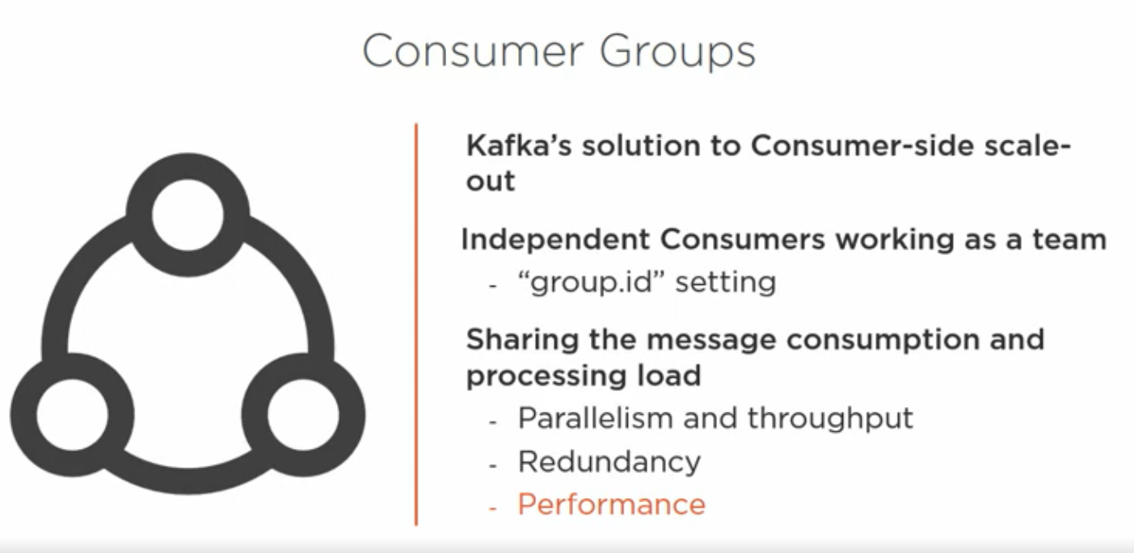

Consumer Groups

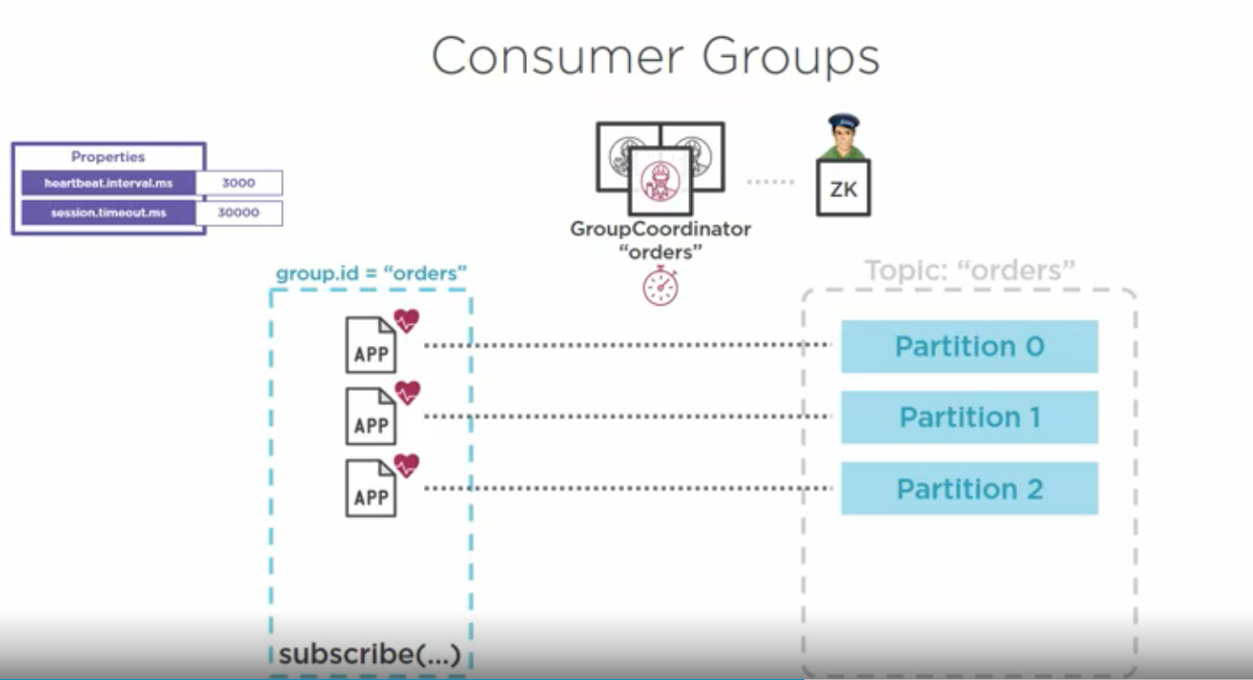

2 failure of one consumer

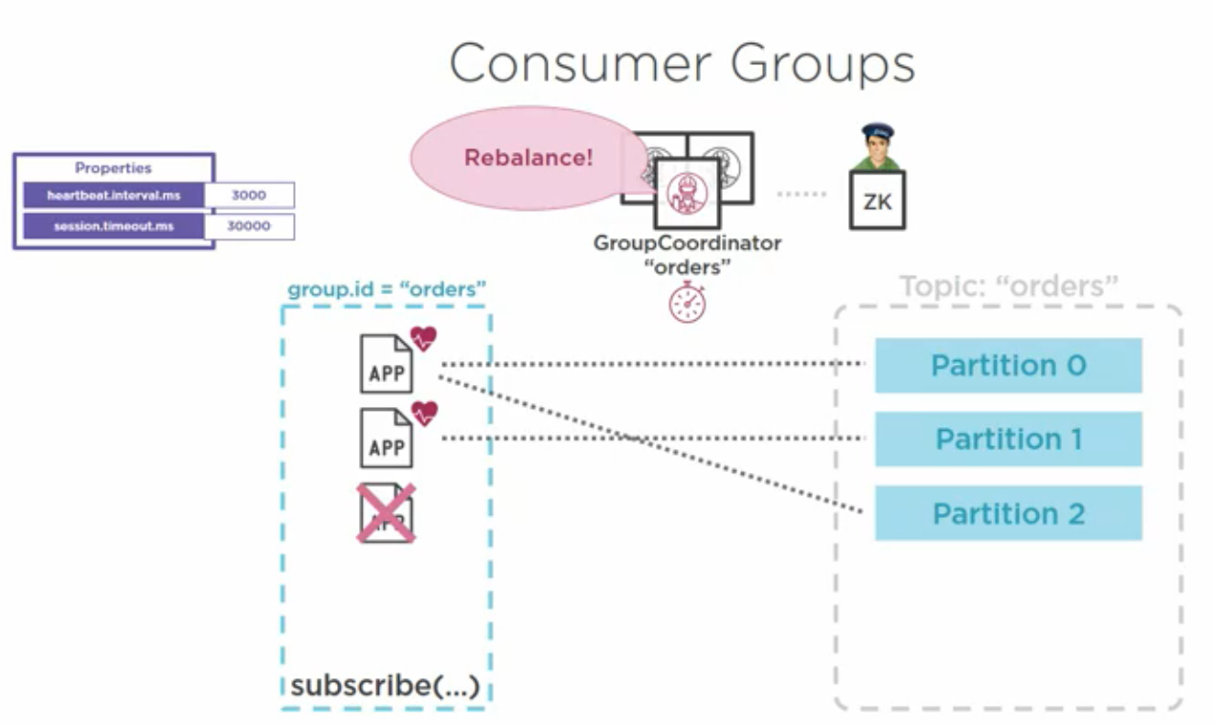

3 Addition of new partition

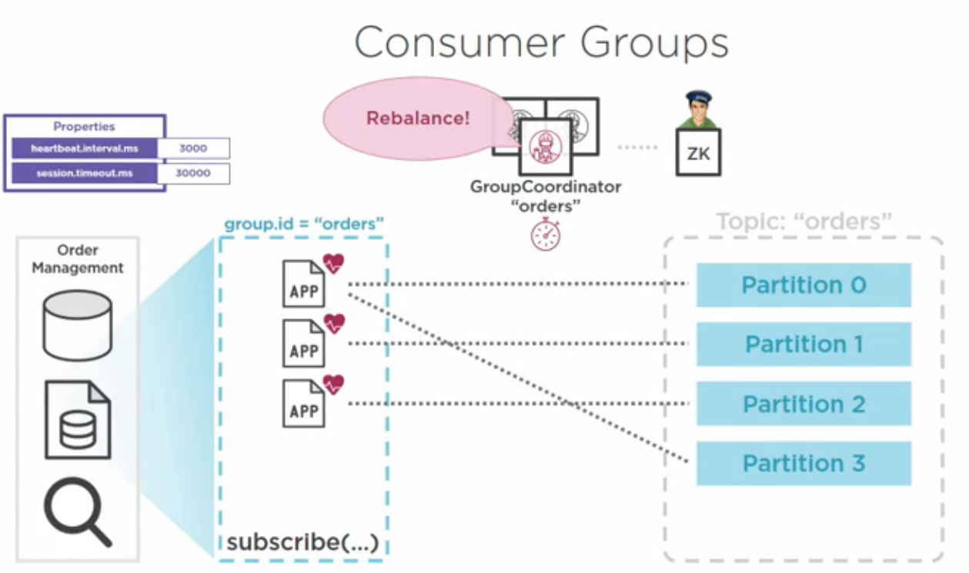

If a consumer is assigned a new partition due to failure of another consumer

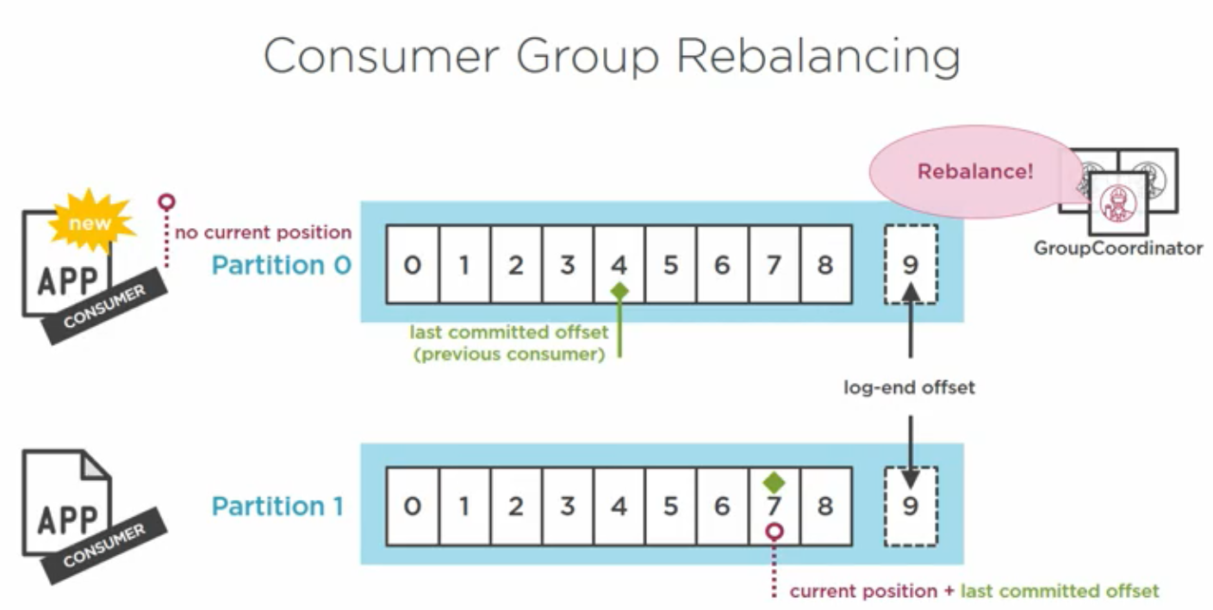

Group Coordinator

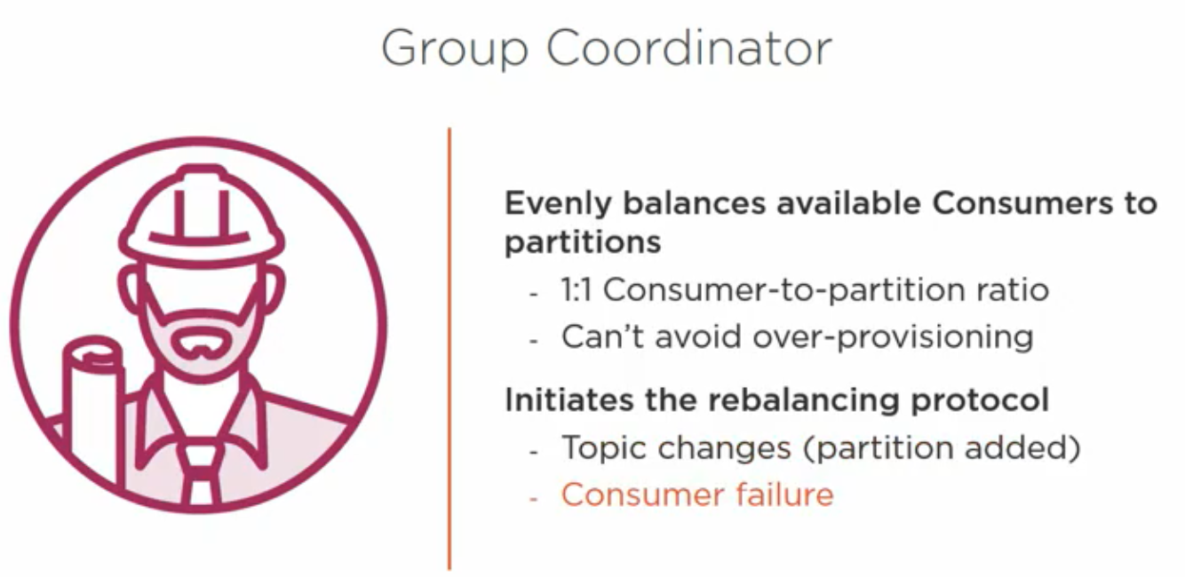

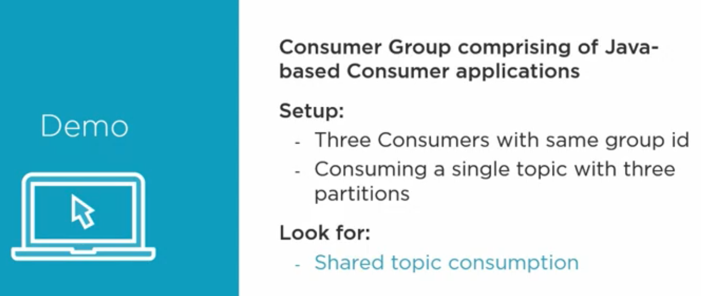

Kafka consumer group App

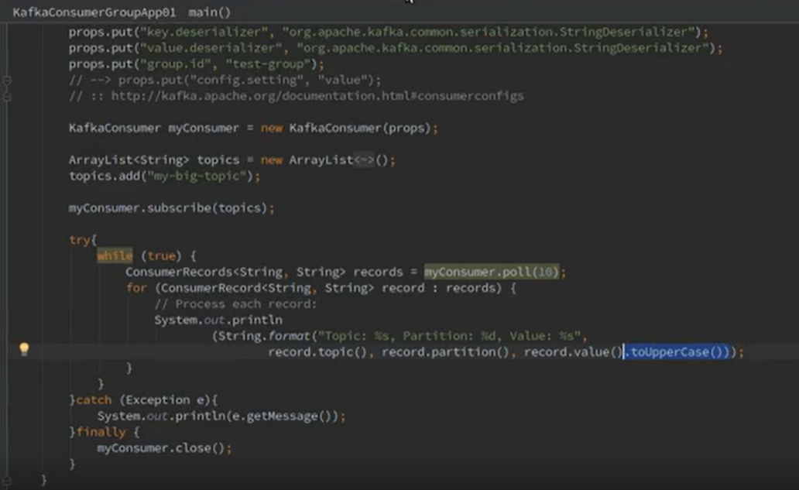

Kafka Group producer app

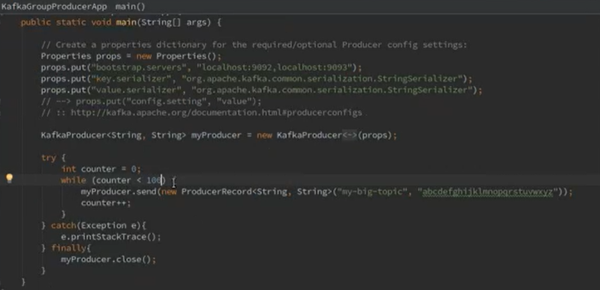

Advance consumer configuration

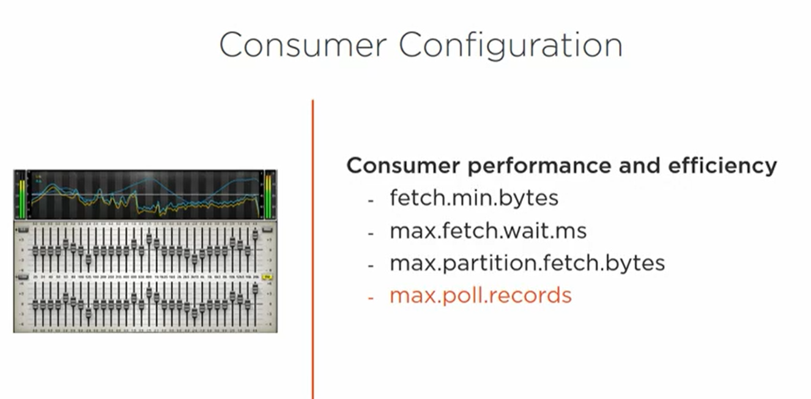

Advanced topics

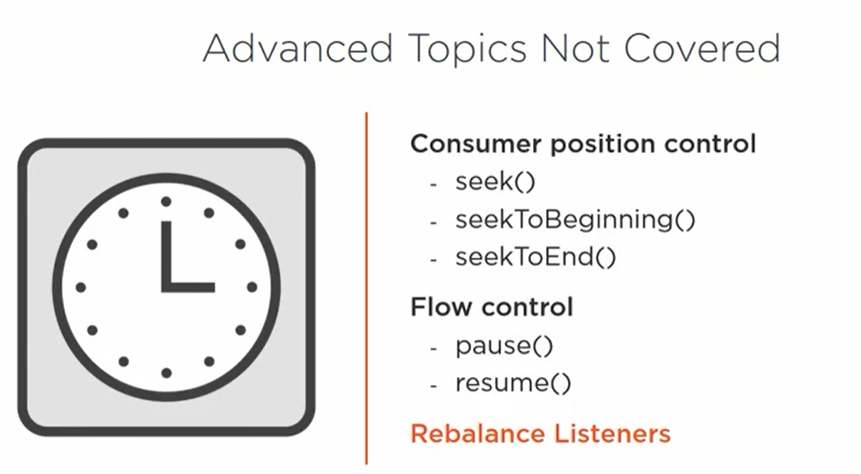

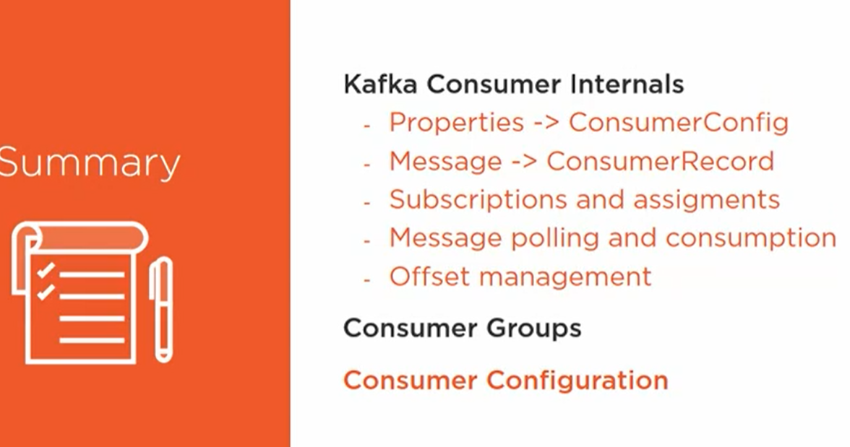

Kafka use cases

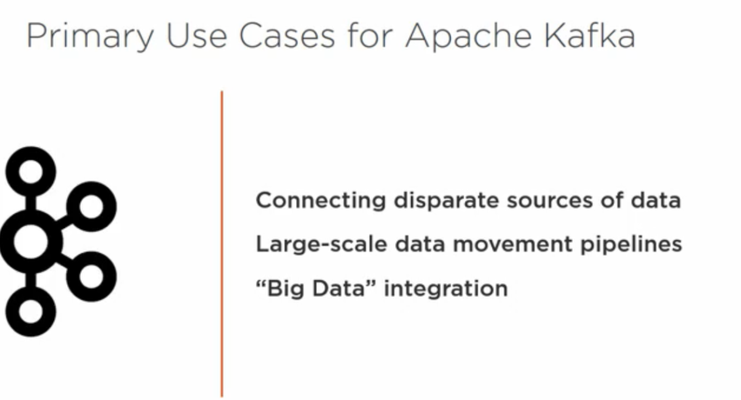

Challenges

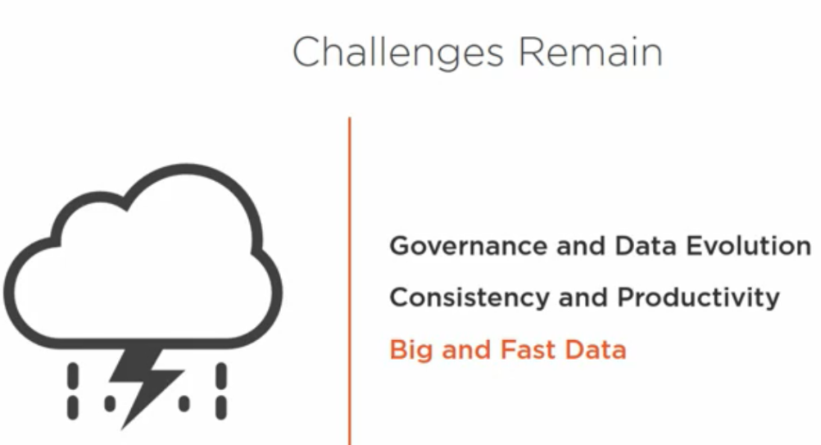

Governance evolution

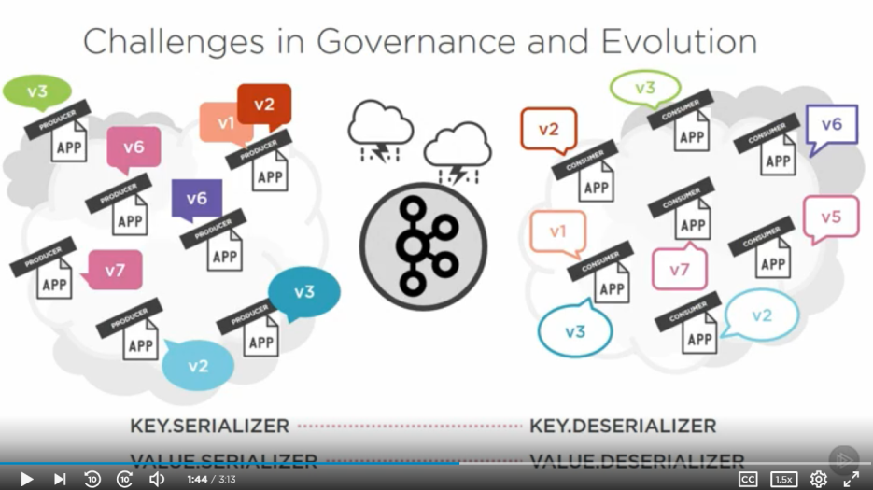

Confluent Avro solution for version control of messages sent and received thru Kafka

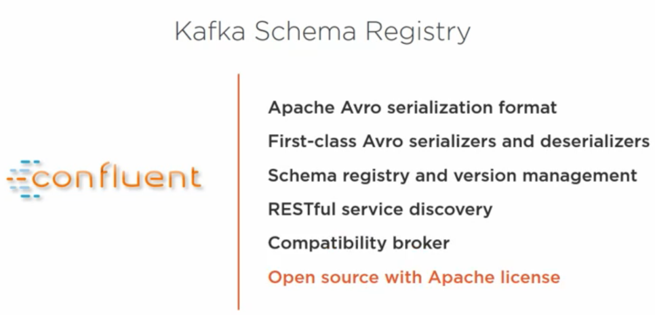

Challenges with different data sources (like different connectors for different RDBMS e.g. Mysql , Oracle, mariaDB )

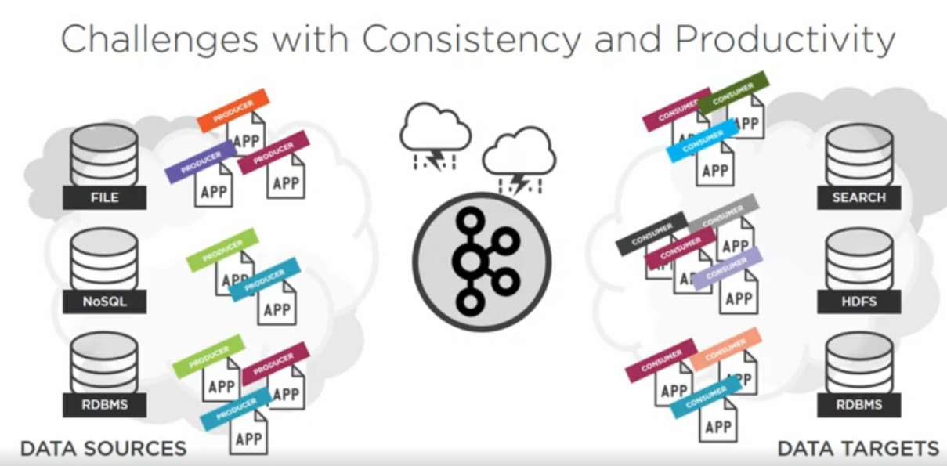

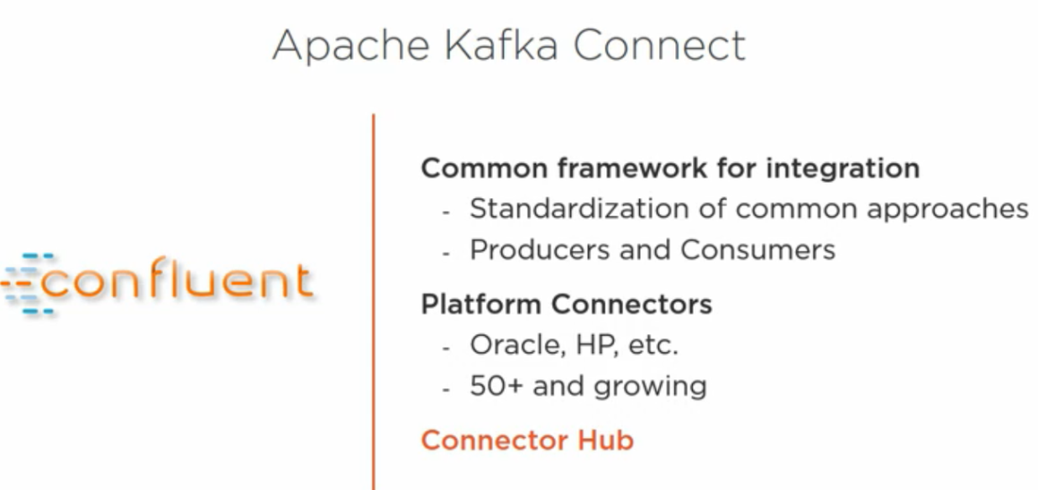

Challenge with fast data and maintaining so many producers and consumers .Also so many tools to manage (especially all being cluster tools)

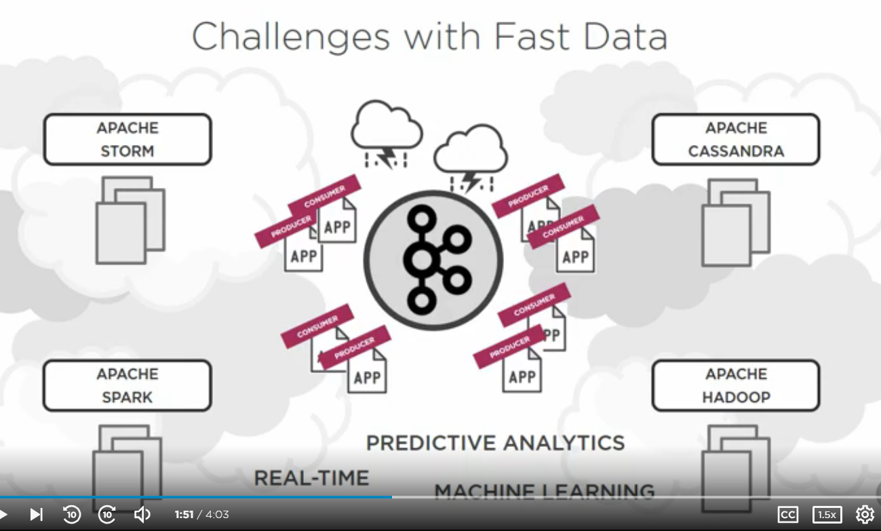

Kafka Stream (one solution for the above problem (all most) it can act as big data as well and completely embeddable with most languages as it is client based solution (client jars available for all languages).

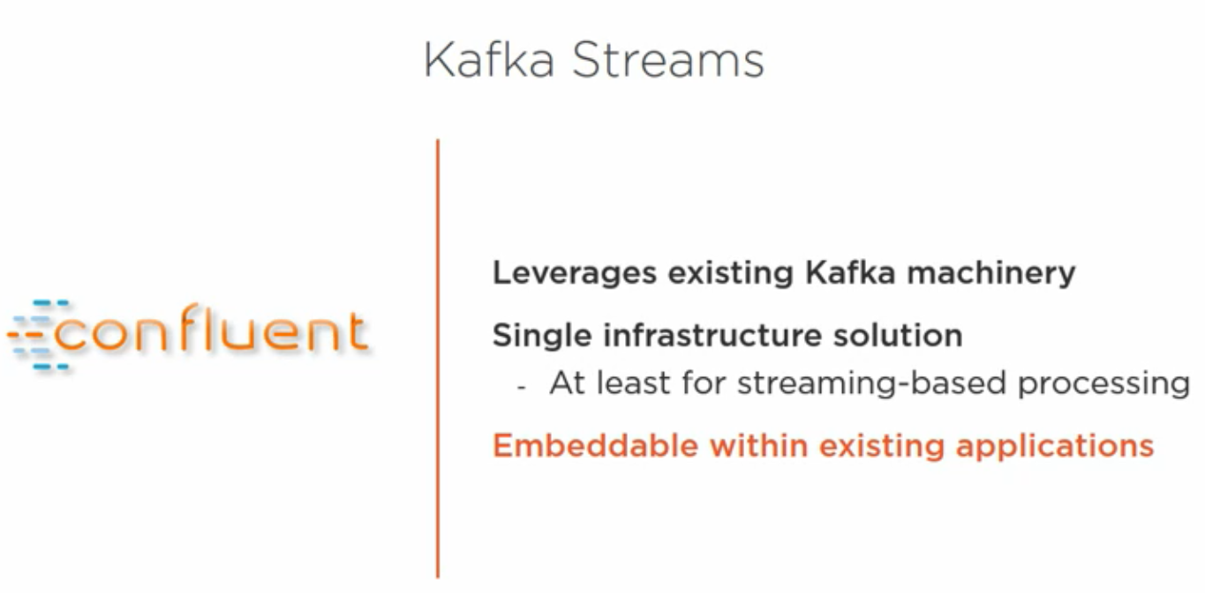

**Apache ecosystem**



